Encompass Dye & Durham Training Workbook
2021 Version 1

Activity 1 Login to Encompass 3
Activity 1b Practice in Training 4
Activity 2 Create a workspace 6
Activity 3 – Begin your Investigations 6
3A. Run a Policy Search 7
3B. Run an ASIC Company Search 13
Activity 4 Work with the Views 16
Overview 16
Chart View 16
Details Panel 17
Workspace Details 17
Documents View 20
List View 22
Activity 4A – Switch Menus 24
Activity 5 – Follow-on Searching 25
Run an ASIC Person Current and Historical Extract 25
Activity 6 – Continue your Investigations 28
Run a PPSR Organisation Grantor Search 28
To Retrieve the PPSR Certificates; 32
Activity 6 – Check Property Ownership 33
Google Maps 35
Activity 7 Share the results 36
Activity 8 – Key Features 38
Add to the Chart 38
Chart Filter 40
Activity 9 - In Product Help 44
Support 44
Notes: 45
Appendix A – Chart icons 46
Appendix B - Types of Searches 51

Activity 1 Login to Encompass
For first time users of Encompass, please complete the following steps.
- Open Encompass using the following link;
https:// dyedurham.encompassuncover.com/

On the Login Page;
- Enter your Username and Password.
Note: Check ‘Remember me’ to prevent you having to enter your details each time.
- Click Login
- First time users, please accept the Encompass Terms and Conditions (check the box).
- Click Accept terms & conditions and continue.
Your encompass dashboard displays.
Congratulations you have completed Activity 1
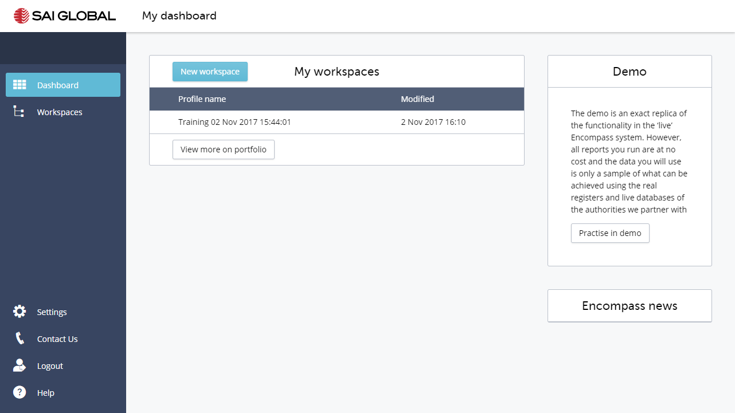
At this point you are in the Production system and will commence with live searches from here.

Activity 1b Practice in Training
- Click on the Practice in training button. You will be taken to an area that is exactly the same as what you will experience in Production but where searches are free of cost.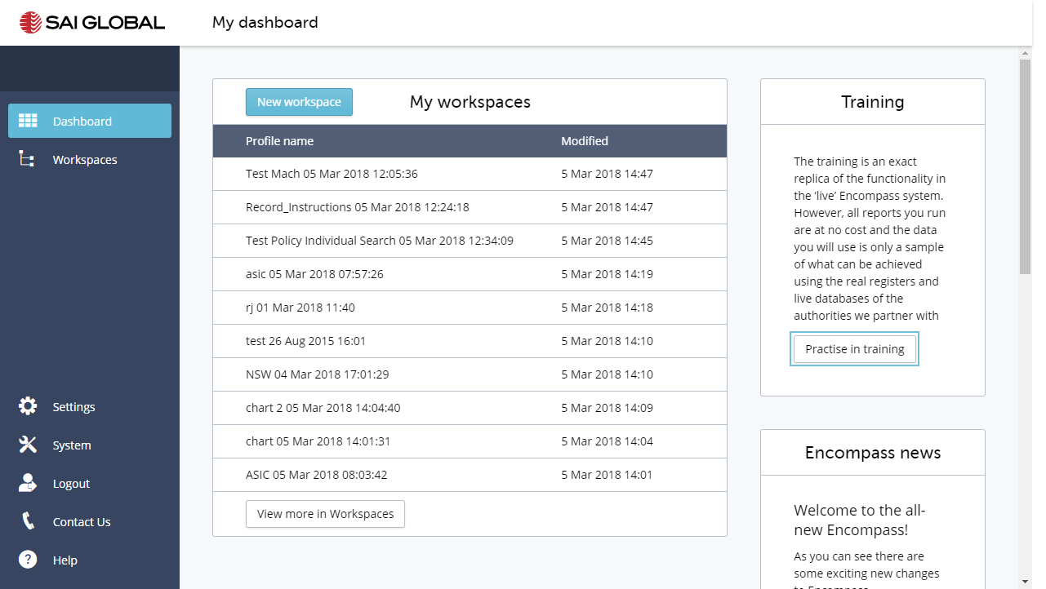

- You will be taken to the Training environment. Make sure you see the Training Environment displayed.
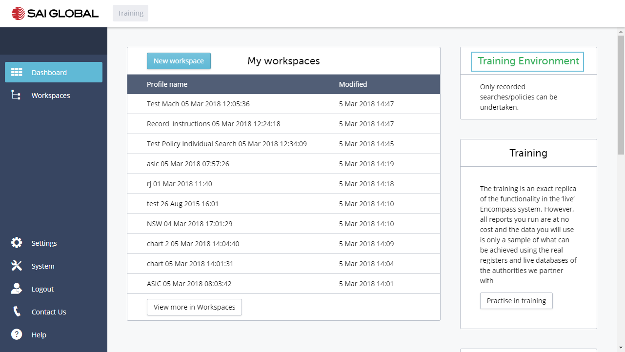
- Click on the Help. You will see a Suggested article – Training Instructions.
- Click on the link
- Click on This will open the article in a new tab of your Browser.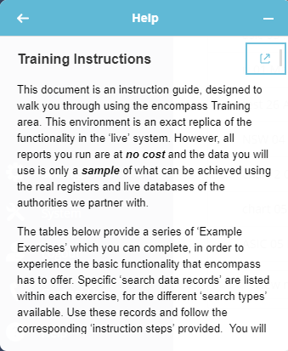

Congratulations you have completed Activity 1b

Activity 2 Create a workspace
- Click on New workspace
- Enter a Customer Reference. This is a reference you will use for the case you are working on.
- Click Create new
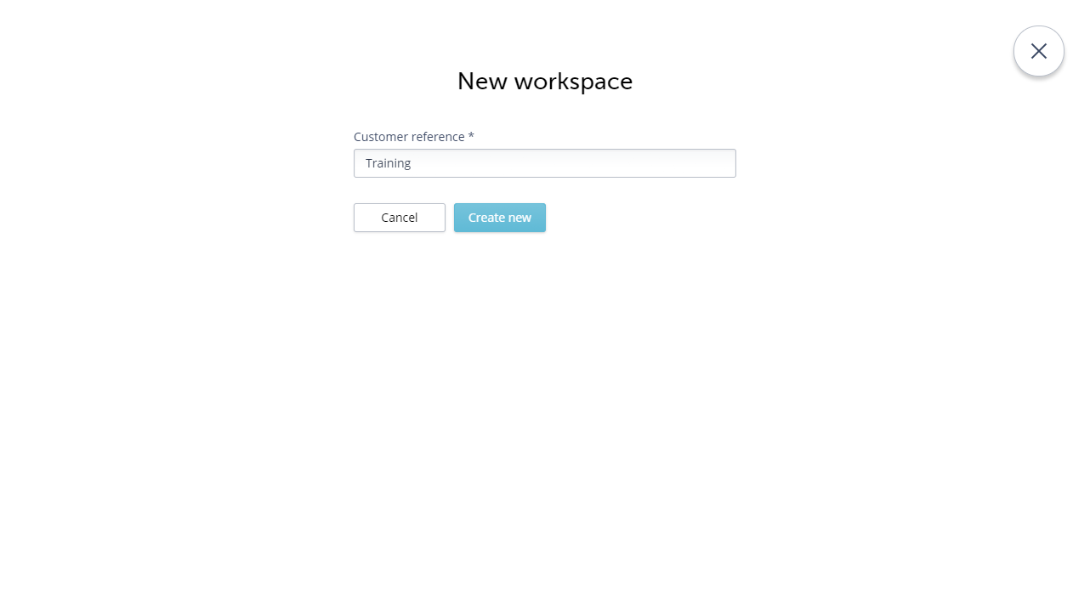
Congratulations – you have completed Activity 2

Activity 3 – Begin your Investigations
In the New Search overlay;
You can filter the searches by Type; Organisation, Person, Property and Document. You will note that the Searches are grouped into two categories; Policy and Information.
Policy - A policy is a set of automated pre-defined searches and rules that automatically run to deliver the content gathering phase of your process. encompass includes three Standard Policies. However, the encompass Policy builder allows for easy customisation of your requirements.
Information - Our extensive pre-built integrations with leading Information Providers, such as ASIC, PPSR, Land Registry and RP Data, provide real-time access to data from a centralised location.

3A. Run a Policy Search
- Expand Policy Search
encompass includes three standard policies.
- Select Basic Beneficial Owner
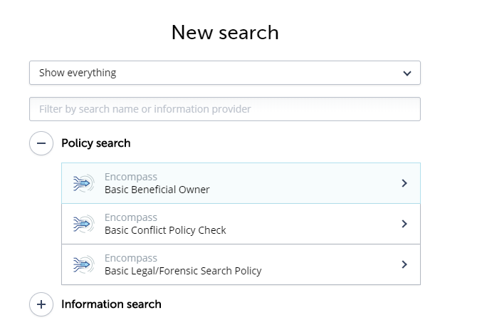
- To see the structure of the Policy, click on the Policy Structure button. encompass will display the make-up of the policy.
  - In this Basic Beneficial Owner Policy, an ASIC Company extract is run on the target company.
  - For all Company shareholders located, an ASIC Company Current extract will be run.
  - If no Company Shareholders are located an ASIC Person extract will be run on all Shareholders over 25%.
  - Click Back
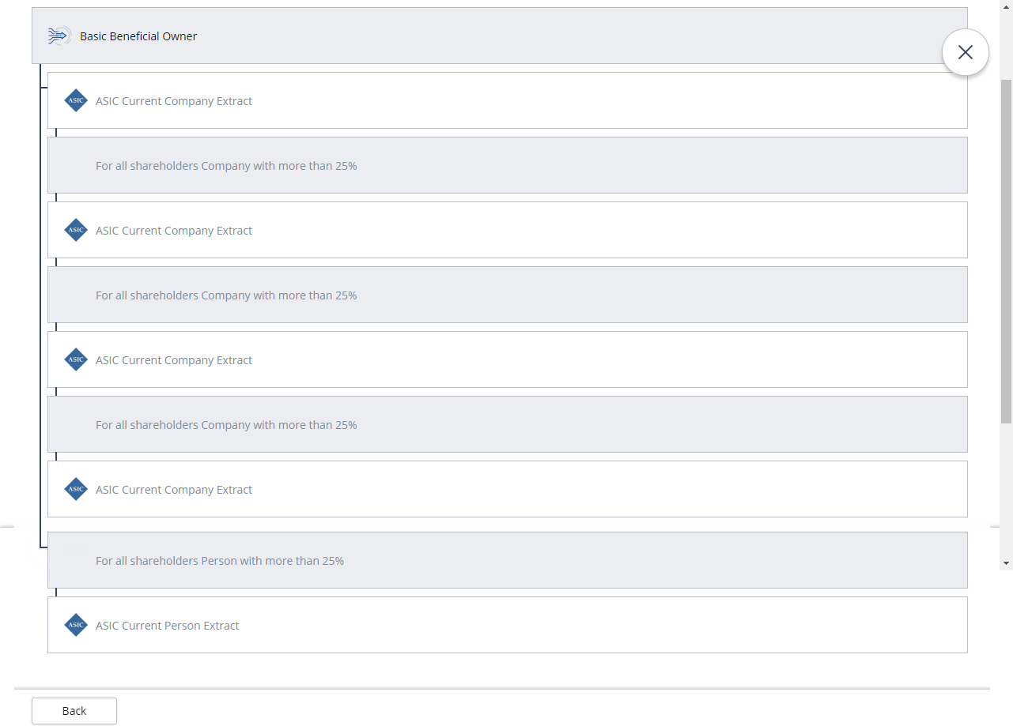
- In the Policy search form, enter the Company Name – please use Mach Technology Group Pty Ltd
You can search using a Company Name or Number
- Click Submit

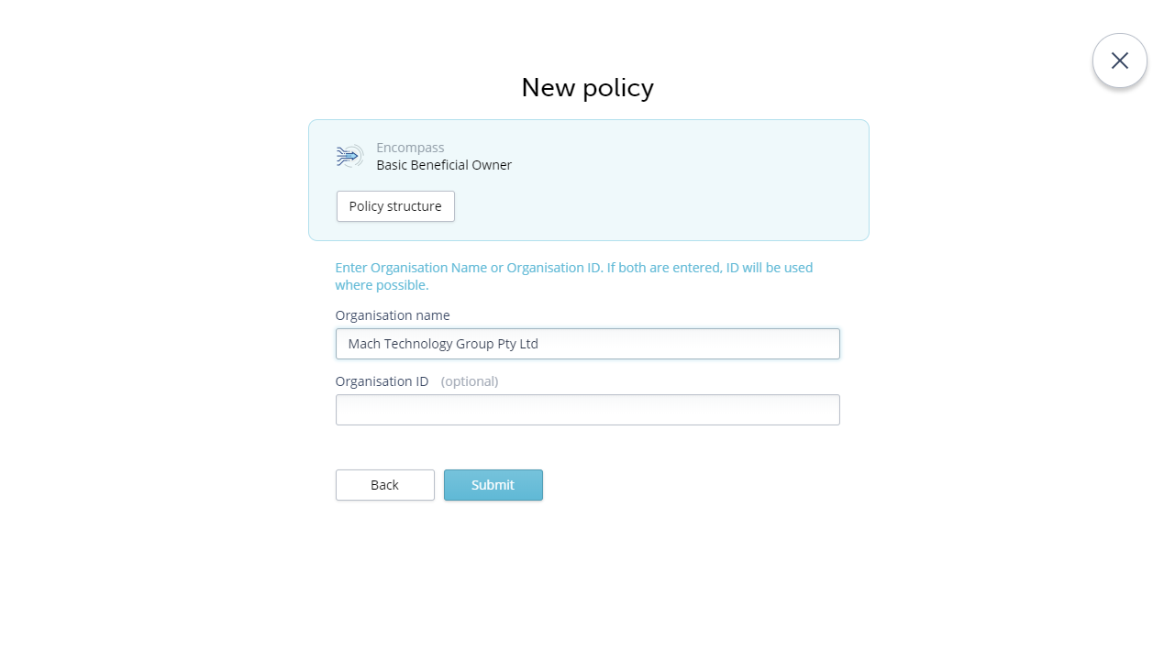

encompass displays the Overview. At the bottom of the view, you will see the policy with a status.
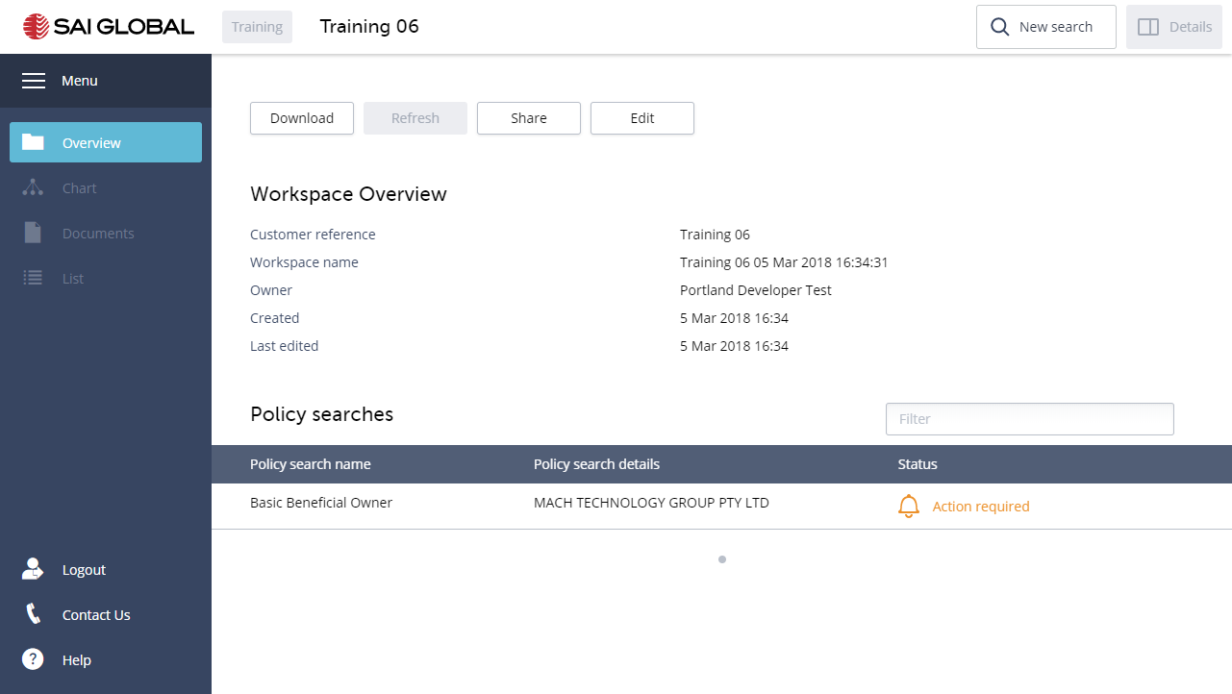
Policy statuses include:
- Pending - Search in progress
- Action required - Indicates that one or more searches within the Policy requires an action. To continue running the policy, an action is required. Click on the Action required link. You may be asked to take an action to:
  - Submit the search as defined in the policy, or Skip the search; and
  - Make a selection when multiple results are returned.
- Success - All searches (orders) within the completed Policy have been successful.
- Refer - Currently means that some of the individual searches in the completed Policy had a status of No Result or Error. A chart is created, and all documents/reports are returned. Further action can be taken on the profile, as required.
- Risk Identified - One or more searches in the completed policy has been flagged as a possible risk. This may be due to a Person or Company having a Bankruptcy or Disqualified status.
- Click on the link to resolve all searches that have an action required status.
encompass opens the Policy manager where you can see what searches have been received, those with errors, and those requiring actions. The Overall Policy status is shown at the top.
- Click on the action required link for the search. You can resolve the searches with Action required, in any order.
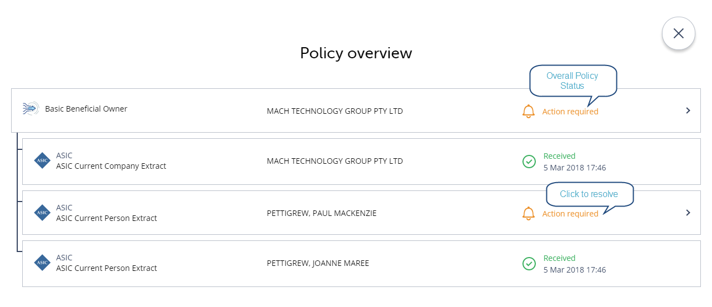
You can filter the results by entering a value in the filter field. The details at the top remind you what search you are actioning.
- Select the record
- Click Submit

Where the results do not match, select a No Match. This will allow the policy to continue.
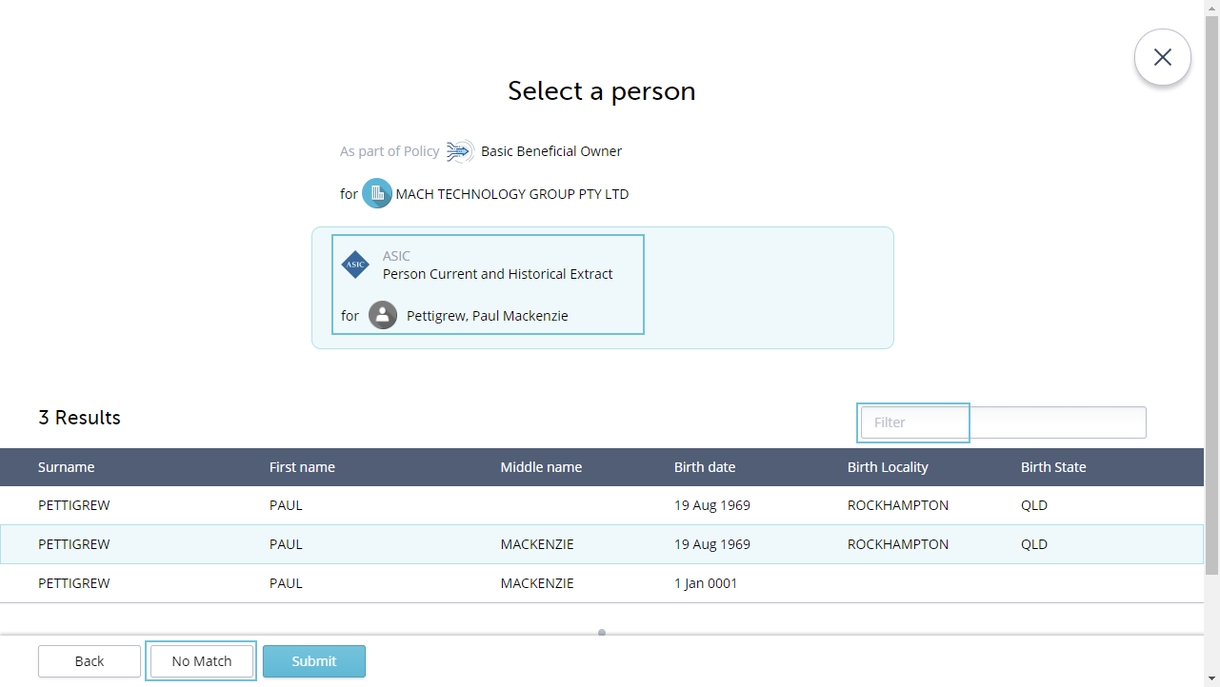
encompass will continue to run the policy.
When all searches in the policy complete, you will see the Policy status updated. In this example the policy has ended with a status of Success.
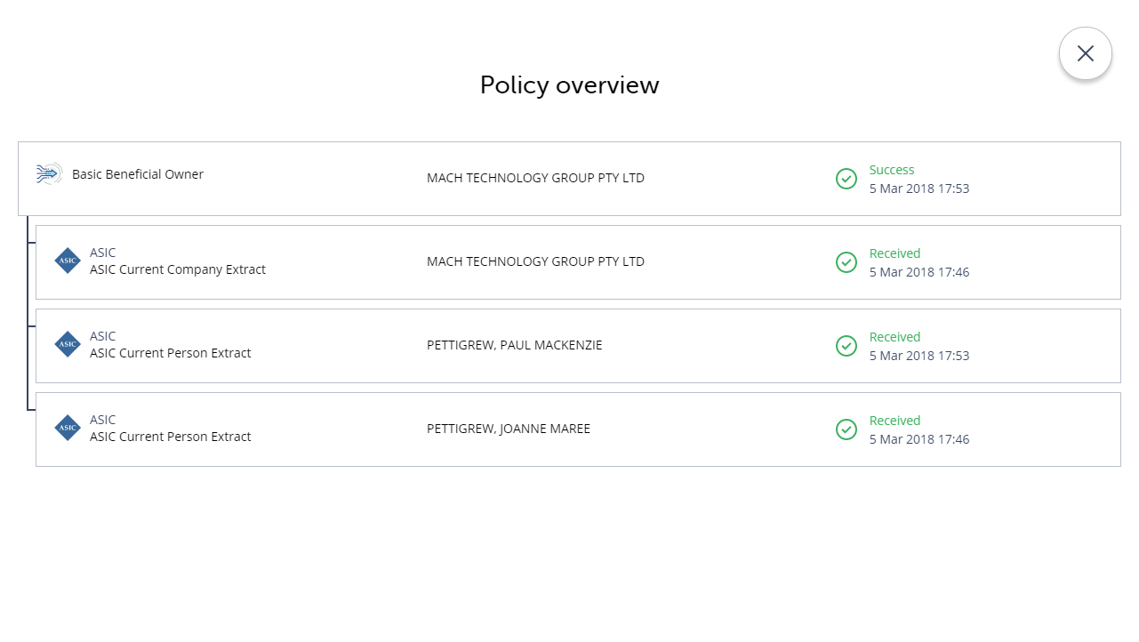
- Close the Policy Manager
encompass displays the Overview where you will see the status of the policy, all the orders completed as a result of the policy, as well as notifications of what other sections have been updated with the results.
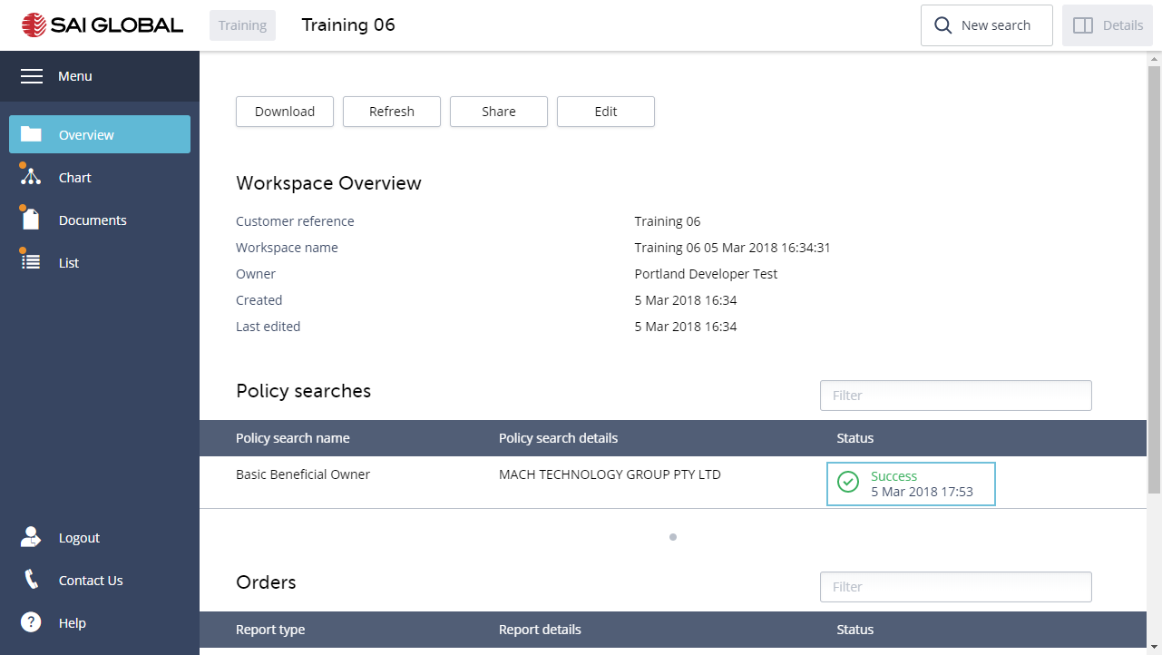
Congratulations – you have completed Activity 3A

3B. Run an ASIC Company Search
You receive a request for a loan application from Mach Technology Group Pty Ltd. You start your investigations with an ASIC Current & Historical Company Extract.
- Select ASIC Company Search
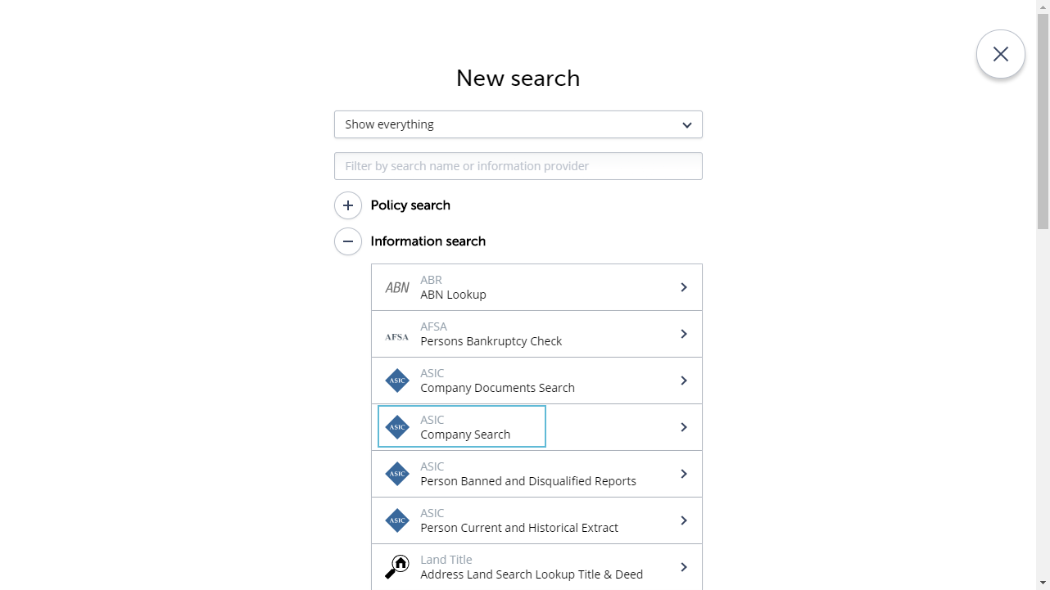
- Enter the Company Name – please use Mach Technology Group Pty Ltd
You can search using a Company Name or Number
- Select the Type of Company on which to Search. The default is Registered and Reserved Company Names.
CURRENT/ RECENTLY DISSOLVED: All live companies and those dissolved in the last 12 months.
DISSOLVED COMPANIES: All companies dissolved in the last 20 years.
PREVIOUS NAMES: This will search against all previous company names (where a company has changed its name) for a period of 20 years.
PROPOSED NAMES: This is a list of proposed names that have been submitted to Companies House and may be used to incorporate or change the name of an existing company.
- Click Submit
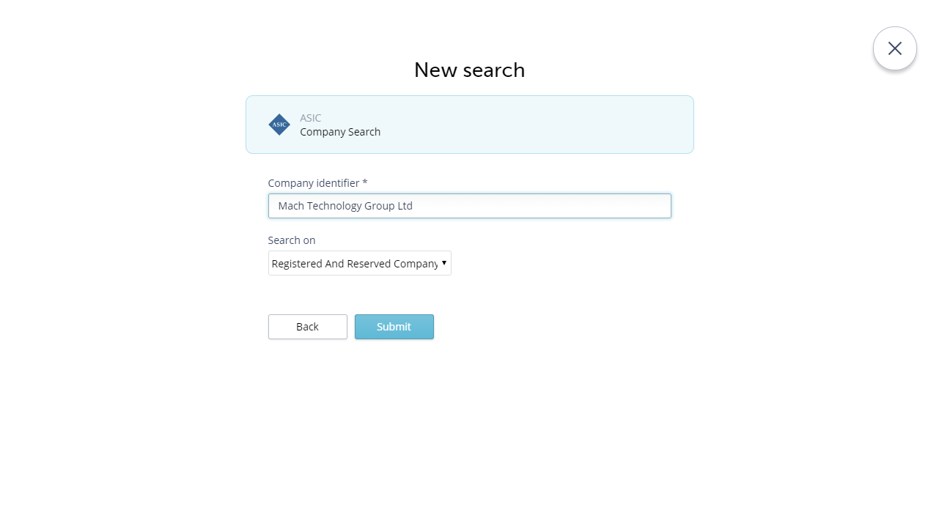
- Select the correct record. In this example please select ACN 115162564.
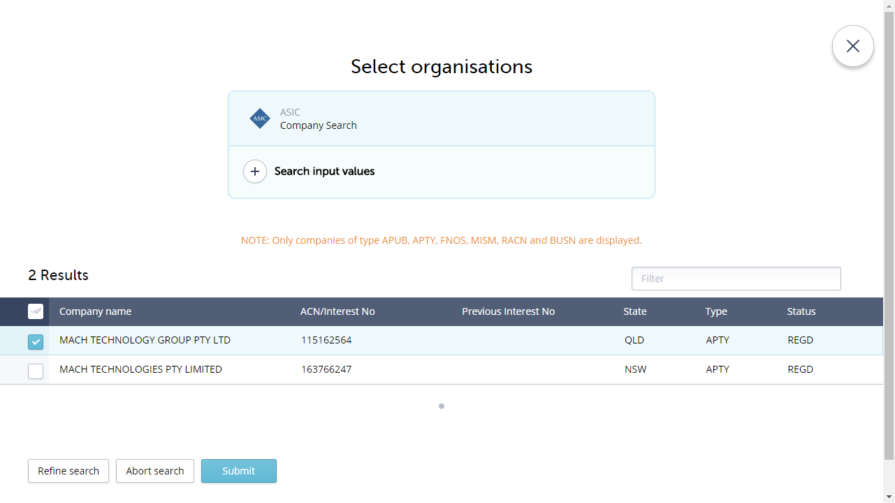
encompass displays the option to purchase three different reports.
- Select extract/s you require to purchase. Please select the Current & Historical Extract.
- Click Submit
In the Training Environment – no costs will be incurred.
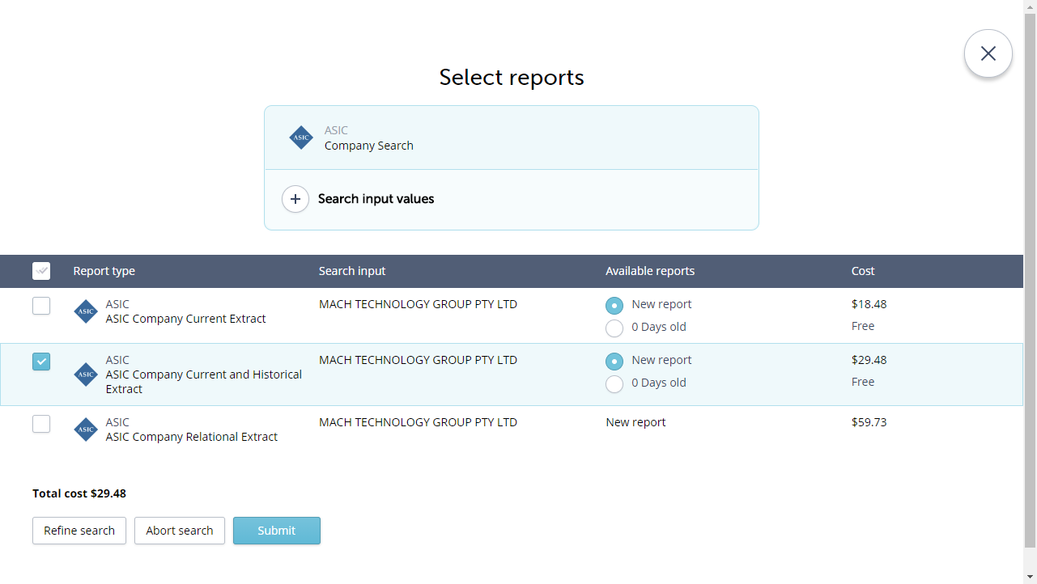
encompass displays the Overview where you will see the status of the order, as well as notifications of what other sections have been updated with the results.
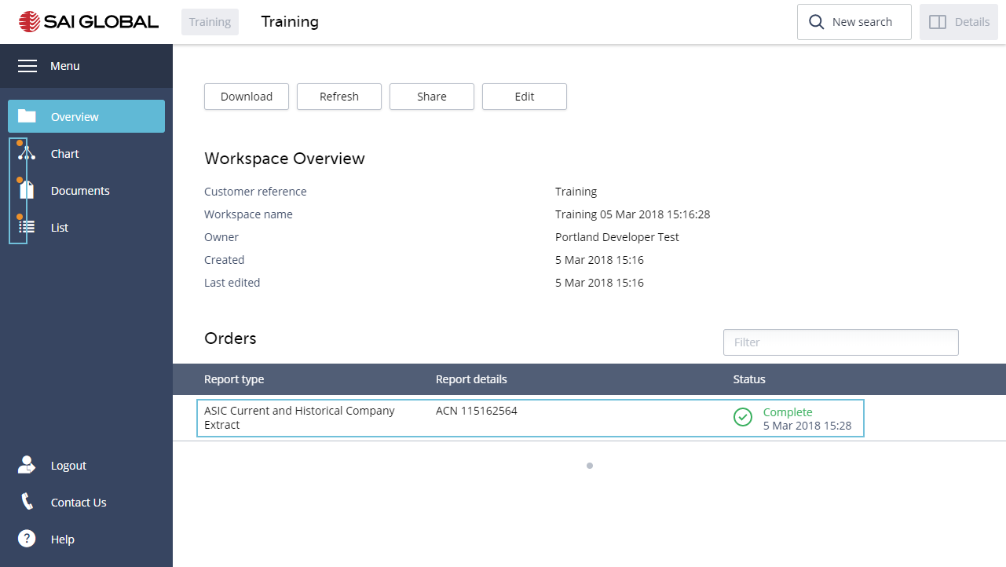
Congratulations – you have completed Activity 3B

Activity 4 Work with the Views
A workspace consists of a number of views for you to work with the results of your search in different ways; Overview, Chart, Documents and List.

Overview
After running a Search, encompass displays the Overview.
In the Overview, you can Download, Refresh, Share and Edit the workspace.
Download - Will download all of your reports, a copy of your chart, the html link to the workspace, and any attachments. The files are contained in an archived file (.zip).
Refresh - Allows you to re-purchase all the reports in the workspace in a single transaction. encompass will include a Refresh report indicating what has changed in the data.
Share - Allows you to copy a link that will provide access to the workspace. You can then send the link to a colleague or client. You can select whether to send a link where the recipient will be able to make changes to the profile or to view the details only.
Edit - Allows you to edit certain fields of the workspace; Name, Next review date and the Status.
The bottom section of the Overview provides details of the Searches and related orders and the status of those; completed or unsuccessful.

Chart View
- Click on the Chart view
encompass analyses the data it receives from a search, and creates a chart representing all the entities and their relationships.
A variety of tools have been included for you to work with the chart. Some of these are:
Filter field - Allows you to search for text that appears on any label in the chart. As you start typing the results will display dynamically.
Chart navigation controls - Use these controls to centre the chart, change the cursor to a selector (pointer) or a hand (grab), zoom in and zoom out.
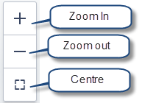
For an explanation of all the Toolbar buttons and how to use these – please refer to the encompass knowledge centre.
- Click on Help from anywhere in encompass, and if the Top suggestions are not what you are looking for, please search.

Details Panel
In the Chart and List views, a Details panel provides you with fundamental information about the workspace as a whole (when no specific entity is selected), or for a specific entity (when one is selected).
Located at the top of every view you will find the following buttons;
- Click on the button
This will open/close the details panel.

Workspace Details
When no entity is selected, the details panel will reflect all the entities in the workspace, and includes two tabs of information; Entities and Relations.
Entities - this is the default tab, and displays the number and details of all the entities in the workspace. In this example there are 11 Entities; 2 Companies, 7 Locations and 2 Persons. You can expand each entity type to see the details.
Relations - displays information on the relationships of the entities to the Target Company. For example: Immediate Parents, Shareholders and Ultimate Parent. There are 14 relationships in the workspace.
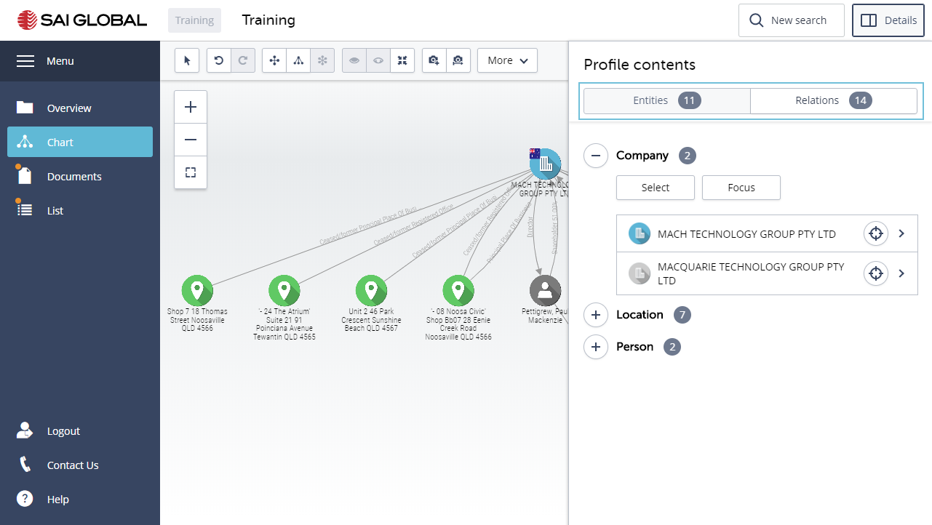
- Click on the focus icon to focus in on the entity (Details tab) or focus in on a relationship (Relations tab). encompass will fade out everything else and leave the entity or relationship in focus. The button will change to Defocus.
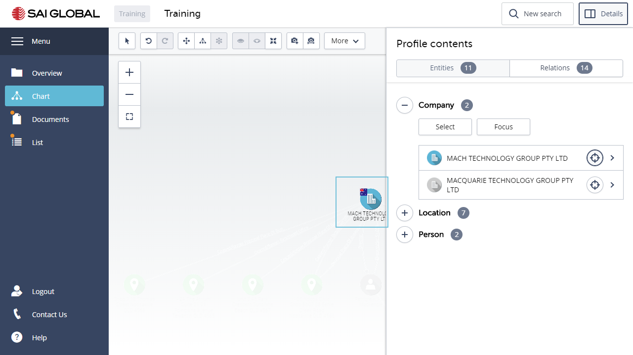
- Click on the arrow to select an entity (Details tab) or a relationship (Relations tab).

Entities tab | Relations tab
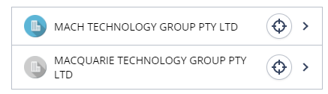 | 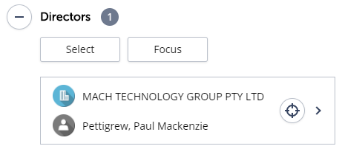
encompass will select the entity or the relationship in the chart and display its details.
Entity Details
When you select an entity, the Details panel will display important information about the selected entity.
Details tab - this is the default tab, and displays the Identification details of the Company, Person, Property or Document. The related original source Documents obtained from the search/es are also displayed, and can be opened from here.
Properties button - Identifies which of the Searches provided the details of the entity.
Add attachment - enables you to upload an attachment (max 10MB). This will append a paper-clip glyph to the entity, and will display the attachment in the Documents view. The attachment is also included in the archived (zip) file when downloading the Profile in the Overview.
- Add an attachment to one of the entities
Add note – allows you to add a note to the entity. This will append a sticky note glyph to the entity and will display the details of the note below the button.
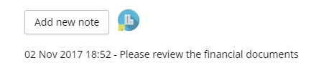
- Add a note to Mach Technology Group Pty Ltd
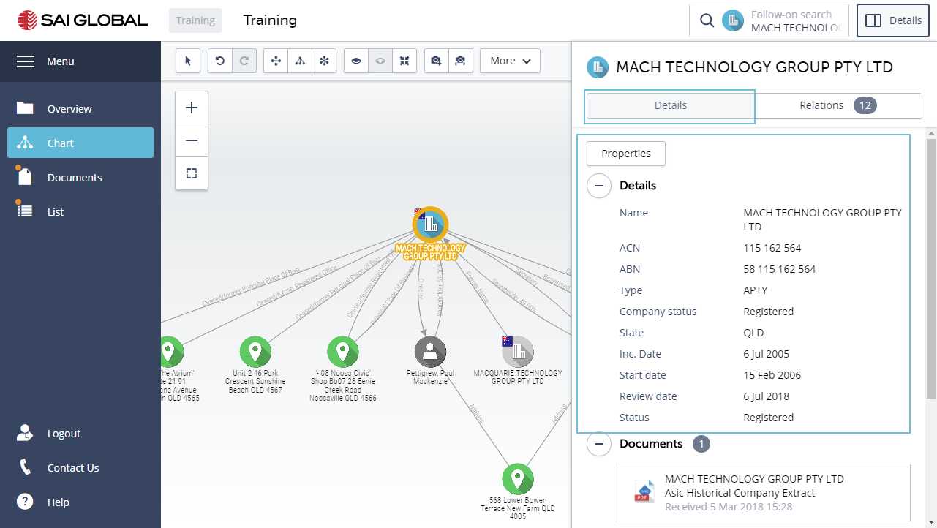
Relationship tab
This tab displays information on the relationships of the selected entity. For example: Director, Shareholder, and Secretary.
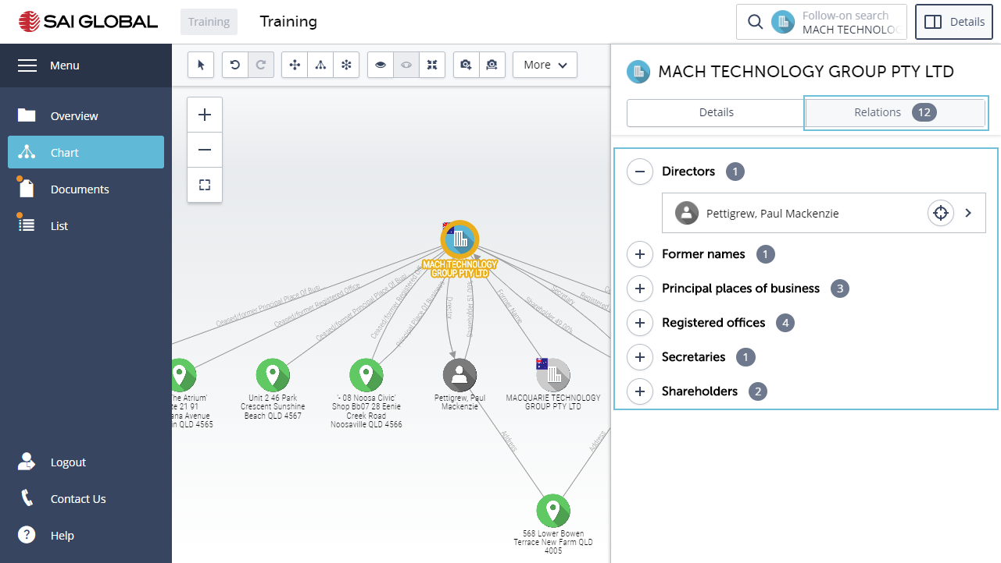

Documents View
- Click on the Documents view
Here you will see the Report downloaded to the workspace as well as a Purchase History document which contains a list of all the reports and related costs purchased in the workspace.
You can select one or more documents and Open, Print, Download or Download a combined PDF. The latter will combine all the selected documents into one PDF document.
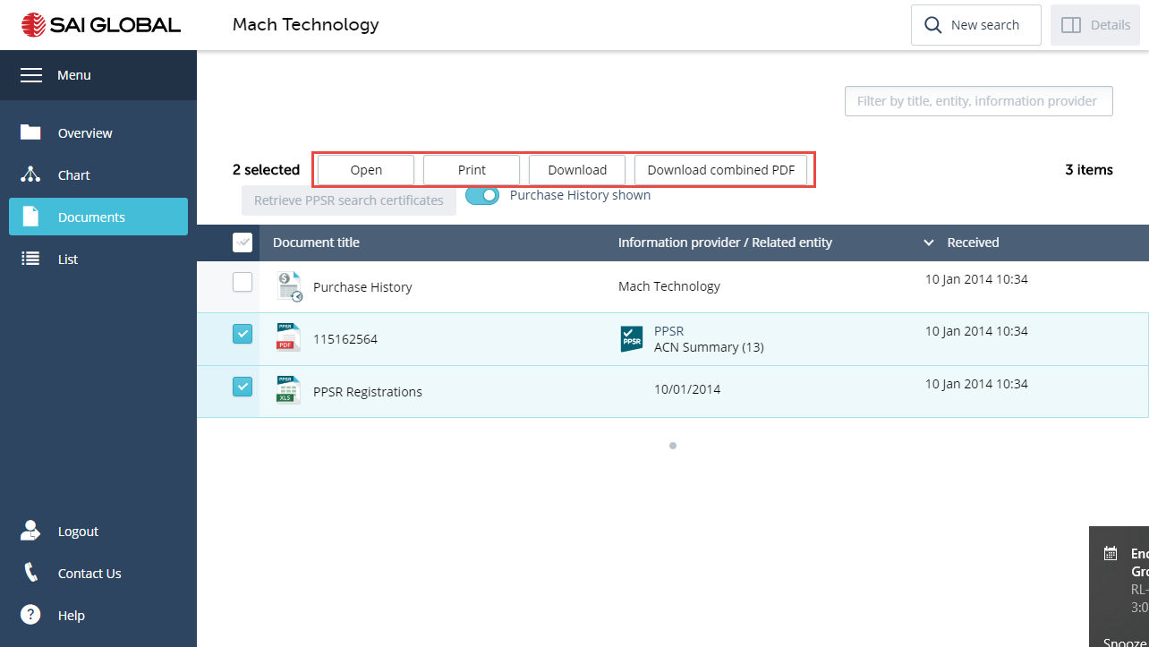
- Click to display the List view
The List view displays all the documents/reports in a list.
The following actions are available in the Documents view.
Download All | This option will download all of your documents/reports in a single pdf file to your PC or local network.
Open All | This option will download all of your documents/reports in a single pdf file to open.
Print All | This feature enables you to combine all the documents/reports into a single pdf document. You can then print, as required.
Download combined pdf | This feature enables you to combine all Reports into a single pdf document, and be able to print all in a single step.
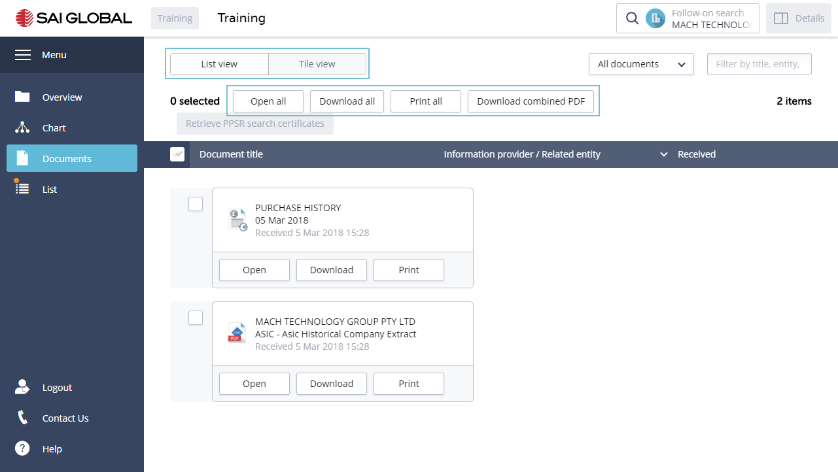
You can also Open, Download and Print an individual document/report or specific documents/reports. Select the document/s/report/s you require, and then click on the relevant button.

List View
- Click to display the List view
For users who prefer to work with lists, encompass includes all the entities in a list.
- Select an entity in the list
- Open the details panel
You can see the same details (Details tab) of the selected entity, its relationships (Relations tab) as you do in the Chart view.
You can export all the data to an Excel spreadsheet.
- Click on the Export button located at the top of the screen.
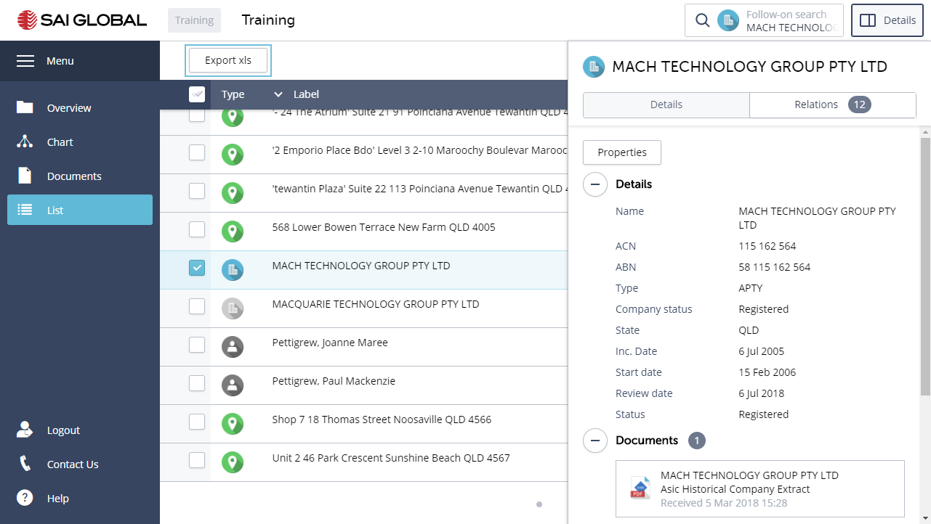
Congratulations you have completed Activity 4

Activity 4A – Switch Menus
There are two menus in encompass.
- The global menu which consists of the following options; Dashboard, Workspaces, Settings, Contact Us, Logout and Help.
And
- The workspace menu which consists of the views of a workspace; Overview, Chart, Documents and List.
- Click on the Menu button to toggle between both menus.
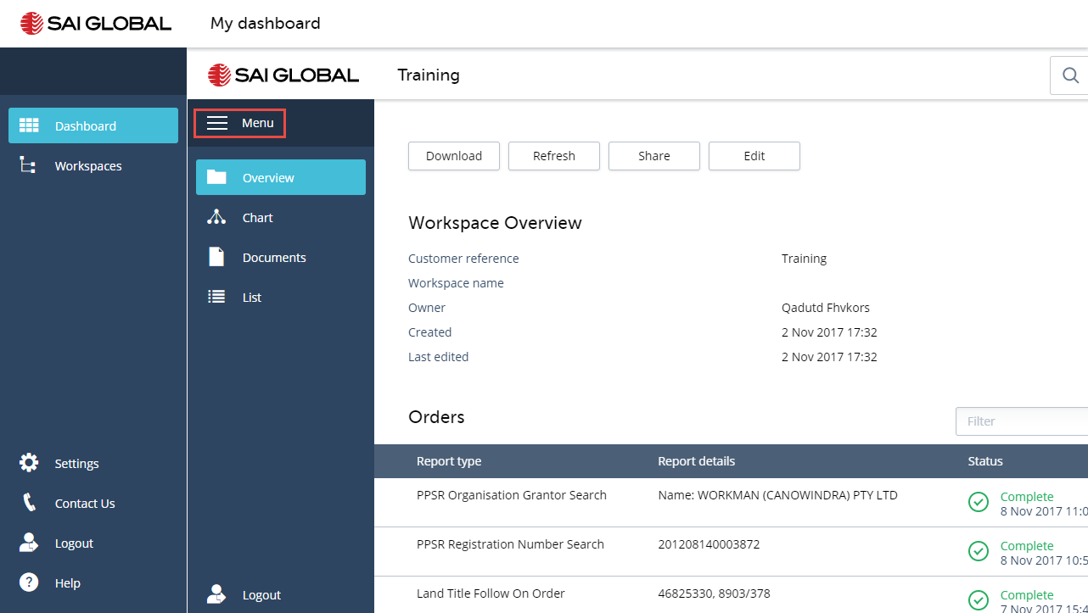
Global menu options
Menu Options | Function
Dashboard | The Launchpad for creating new or opening a recent workspace.
Workspaces | The Workspace manager where you can create new, open, share, edit and archive a workspace. Please use the encompass help centre for guidance on any of these functions.

Settings | This is where you can define if the Purchase History is to be included when you share a workspace (Share); and  where you can change your password (Account).
Contact Us | Where you can submit a support ticket.
Logout | Exit encompass
Help | Launch the encompass Knowledge centre

This completes activity 4A

Activity 5 – Follow-on Searching

Run an ASIC Person Current and Historical Extract
Having determined the Company status and those who hold positions in the Company, you are now interested in one of the Directors, Paul Mackenzie Pettigrew, whose signature is on the application.
You run an ASIC Person Current and Historical Extract on Mr. Pettigrew, to see whether he holds any other positions in other Companies and what the statuses of those companies are.
You can run a Follow-on search from the Chart and List views.
- Open the Chart view
- Select Paul Mackenzie Pettigrew
Once you select an entity, the New Search button at the top of the screen changes to show a Follow-on search for the entity.
- Click on the Follow-on search button or right click and select Follow-on
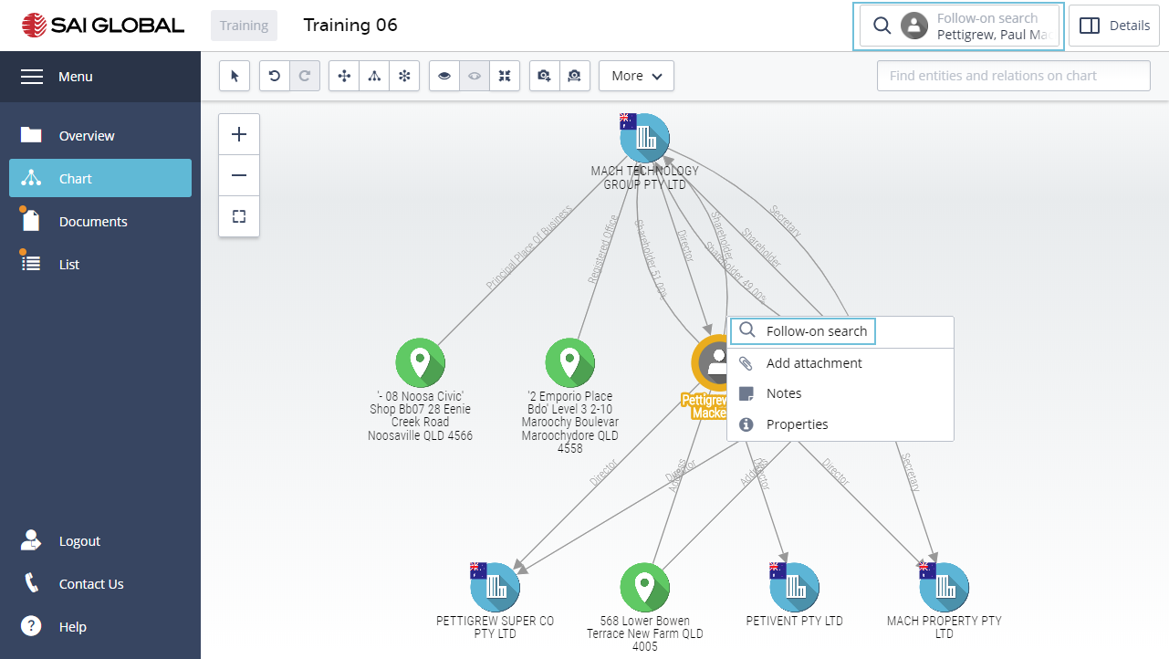
The Follow-on search forms opens and displays the selected entity at the top of the screen. On the left, you can see all the other entities in the workspace. You can select another entity, and the searches on the right will filter to those available for the entity type.
- Select the ASIC Person Current and Historical Extract
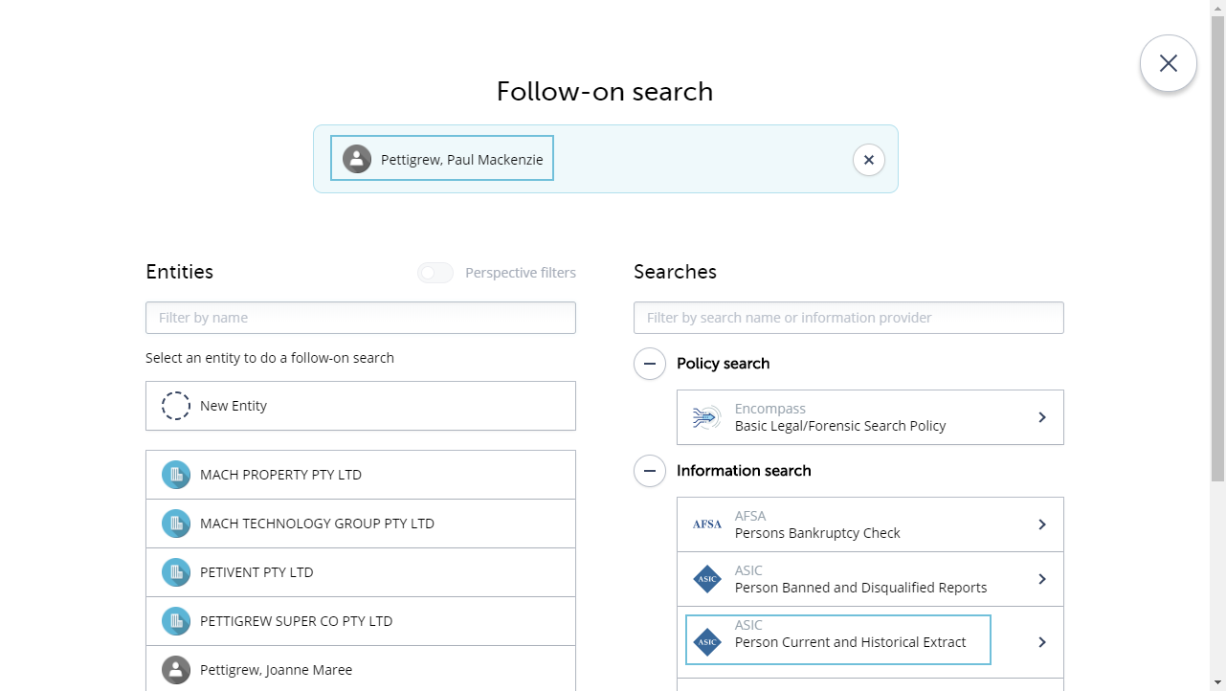
- Select the second record for Paul Mackenzie Pettigrew
- Click Submit
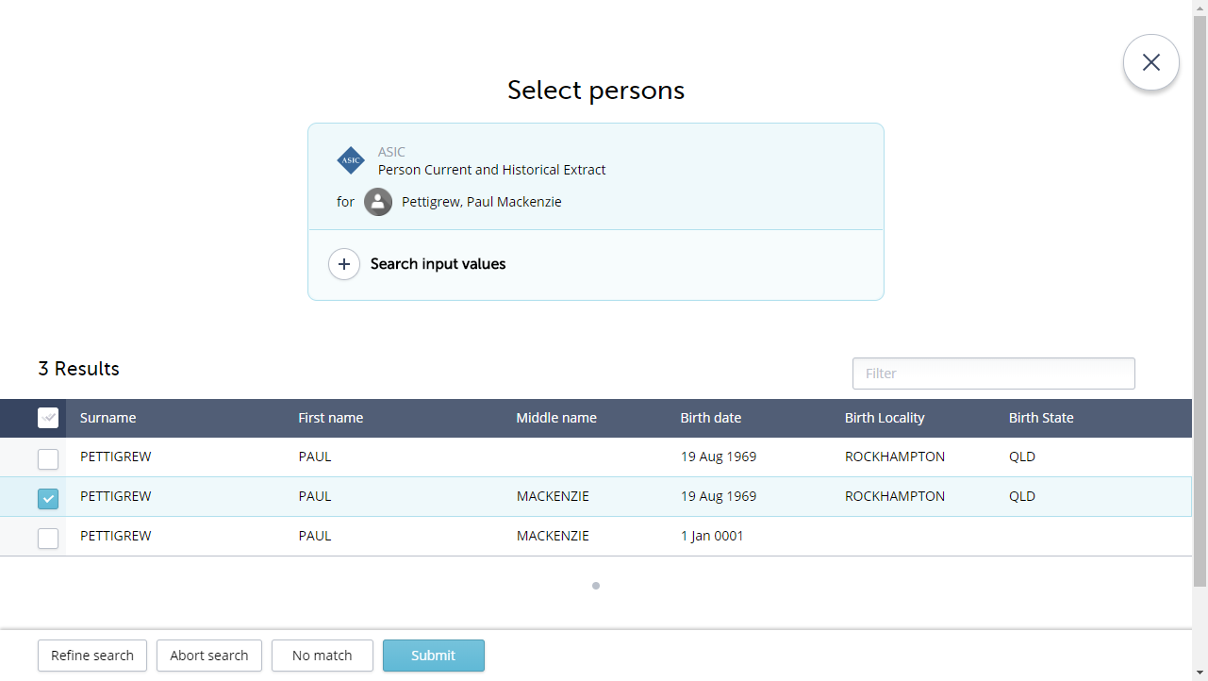
- Purchase a New Report
- Click Submit
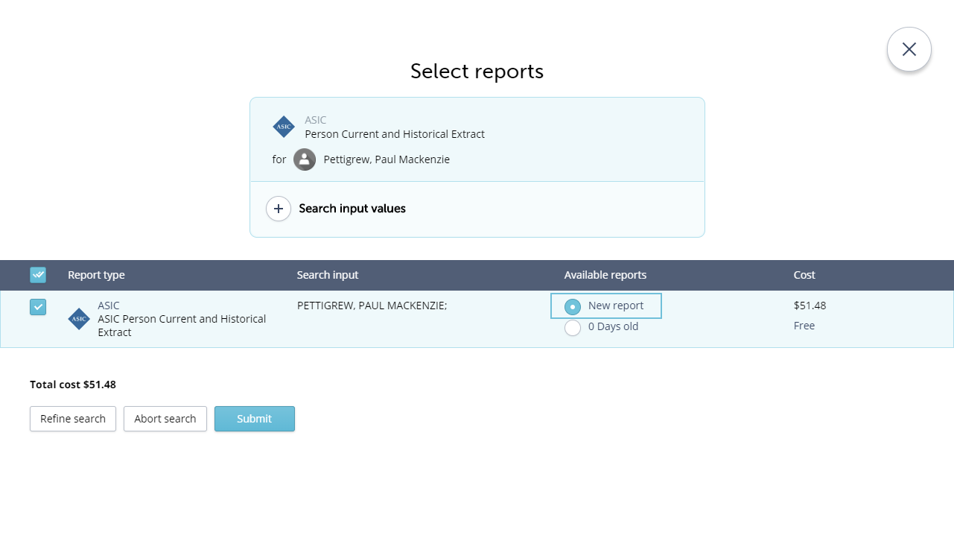
encompass will add the new entities to the right of the Chart.
- Click on the hierarchy layout toolbar button
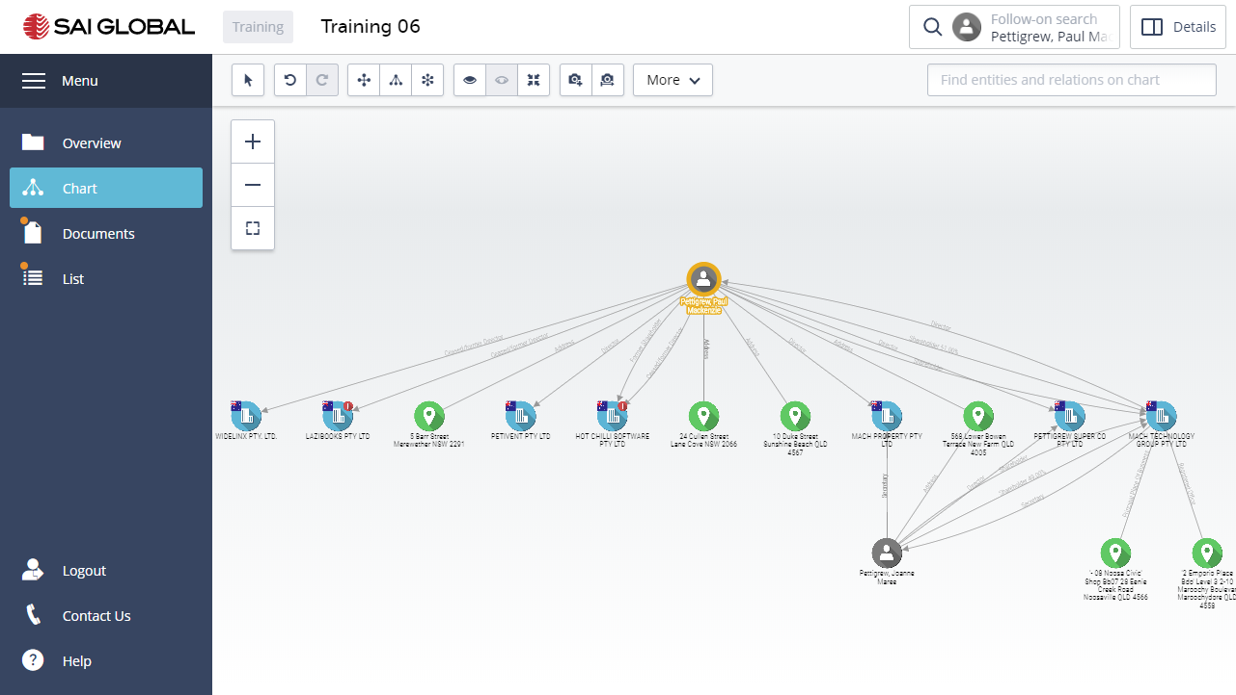
Congratulations you have completed Activity 5

Activity 6 – Continue your Investigations

Run a PPSR Organisation Grantor Search
Before you approve the new loan, you check if the Company owes money against any assets. You run a PPSR Organisation Grantor search to locate Company assets with finances owing.
- Open the List view
- Select Mach Technology Pty Ltd. De-select any other entities.
- Click on the Follow-on Search button
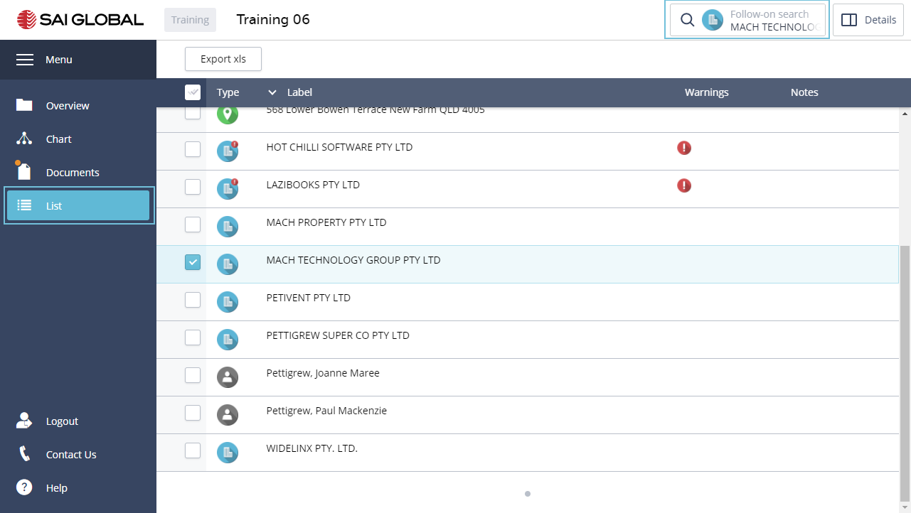
- Select the PPSR Organisation Grantor Search
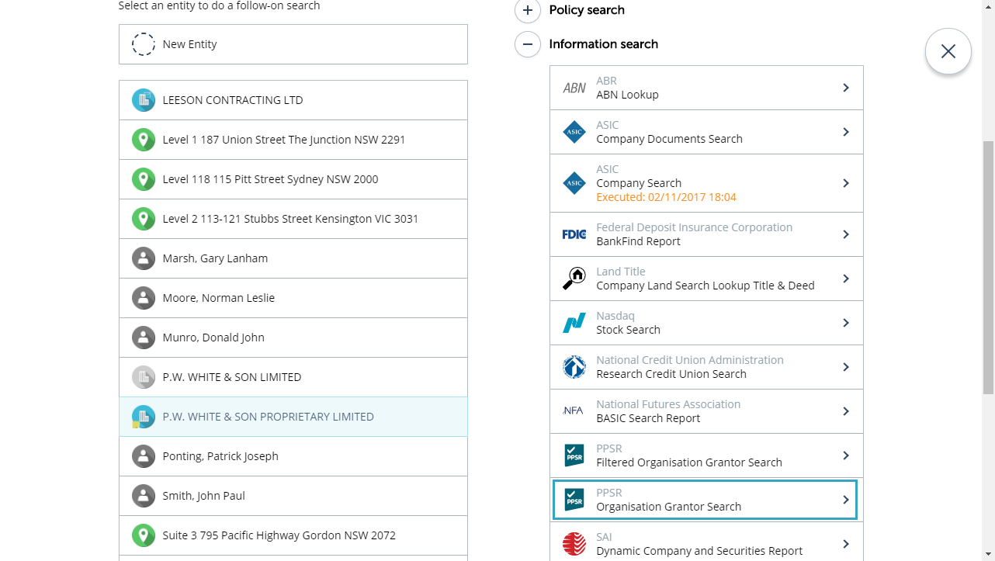
encompass completes the Search form for you with the details it has on the Company from the earlier search.
- Click Submit
encompass completes a Company Browse and lists the available reports. Also displayed is the Company Registration Date to help you to make the decision on what reports to purchase. If the Company was registered prior to Jan 2012, it is recommended that you purchase all the available reports. If registered after Jan 2012, it is sufficient to purchase an ACN report.
In addition, the PPSR reports, encompass also enables you to search against Former names (if they exist in ASIC), the ARBN, ARSNand the ASIC Company Current and Historical extracts.
Please NOTE that the PPSR reports you will get with the search, are the Summary reports inclusive of a summary of the Registrations. These are not the legal PPSR certificates. The Legal certificates can be downloaded from the Documents view (within 24hours) after purchasing the reports.
- De-select the Reports for the Name and ABN (Only purchase the report for ACN)
- Click Submit

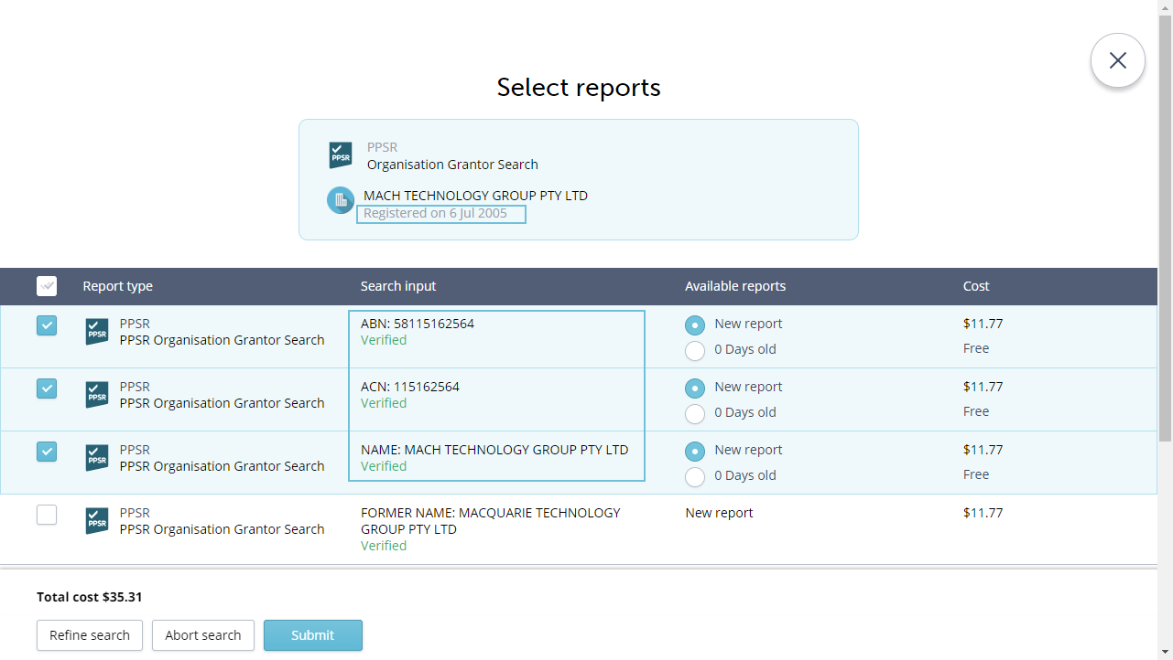

encompass adds the additional entities to the List.
- Sort the list by clicking on the Type column heading
You will see all the assets that the Company holds.
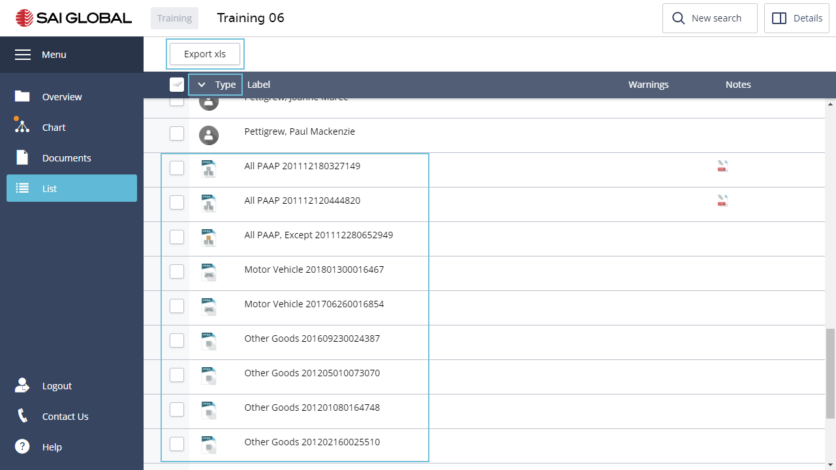
- Click to Export the list.
- Open the XLS Spreadsheet
encompass displays all the data in the workspace, categorised under tabs.
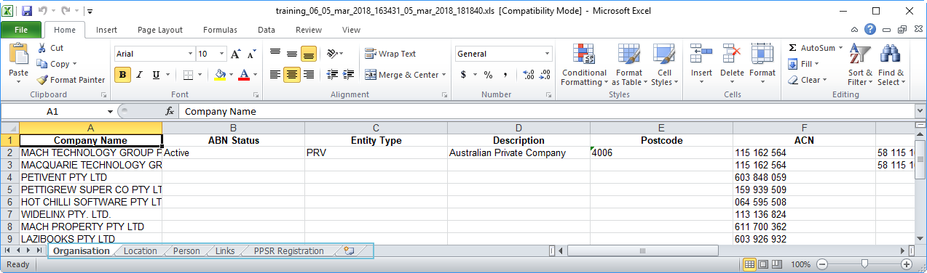
- Open the Chart View
You will note the visual representation of the Assets and Secured Parties.
- Apply a Hierarchy Layout
- Open the Documents View
encompass downloads the PPSR Summary report to the workspace. The Summary report is a customised document created by encompass and Dye &Durham, NOT available if you search directly with PPSR.
An Excel Workbook is automatically generated with all PPSR Registrations.

To Retrieve the PPSR Certificates;
- Click on Retrieve the PPSR search certificates
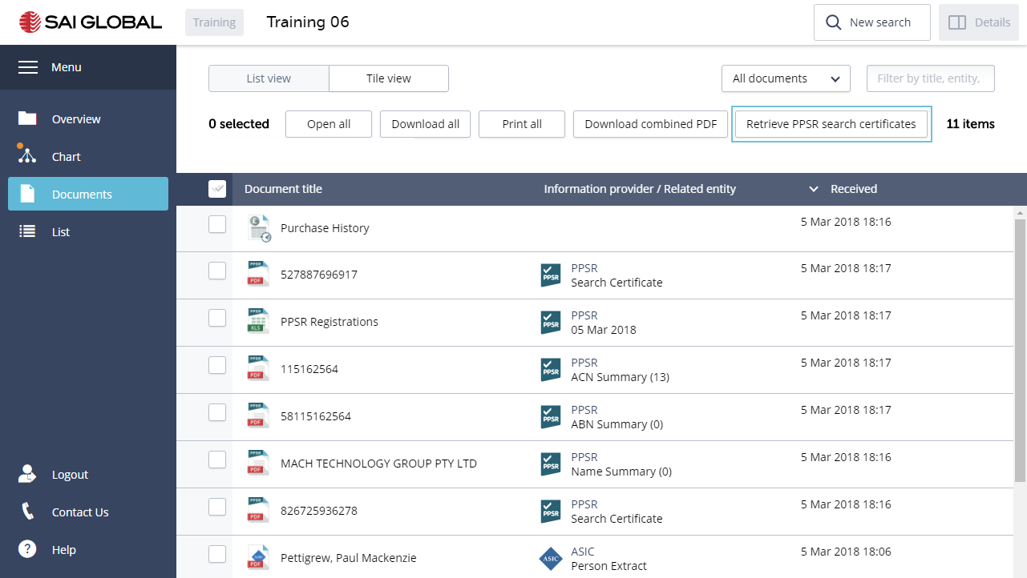
In the Certificates form;
- Click on the heading - Collateral Class. This will sort the certificates.
- Select the Motor Vehicle Certificates
- Click Retrieve selected
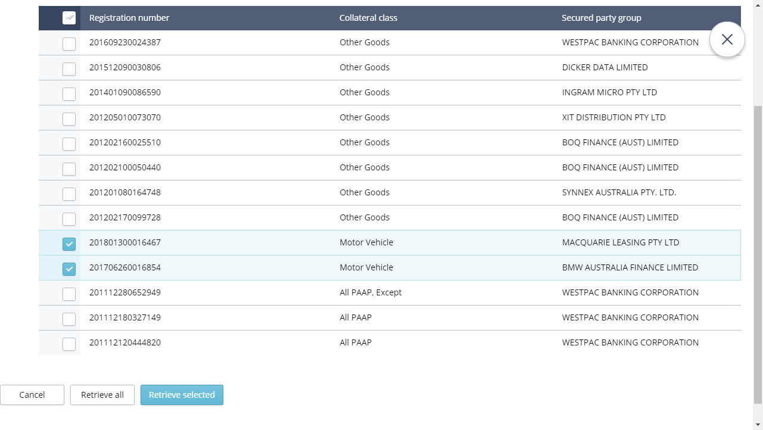
- Open the PPSR ACN Summary Document to see what the customised Dye and Durham report looks like.
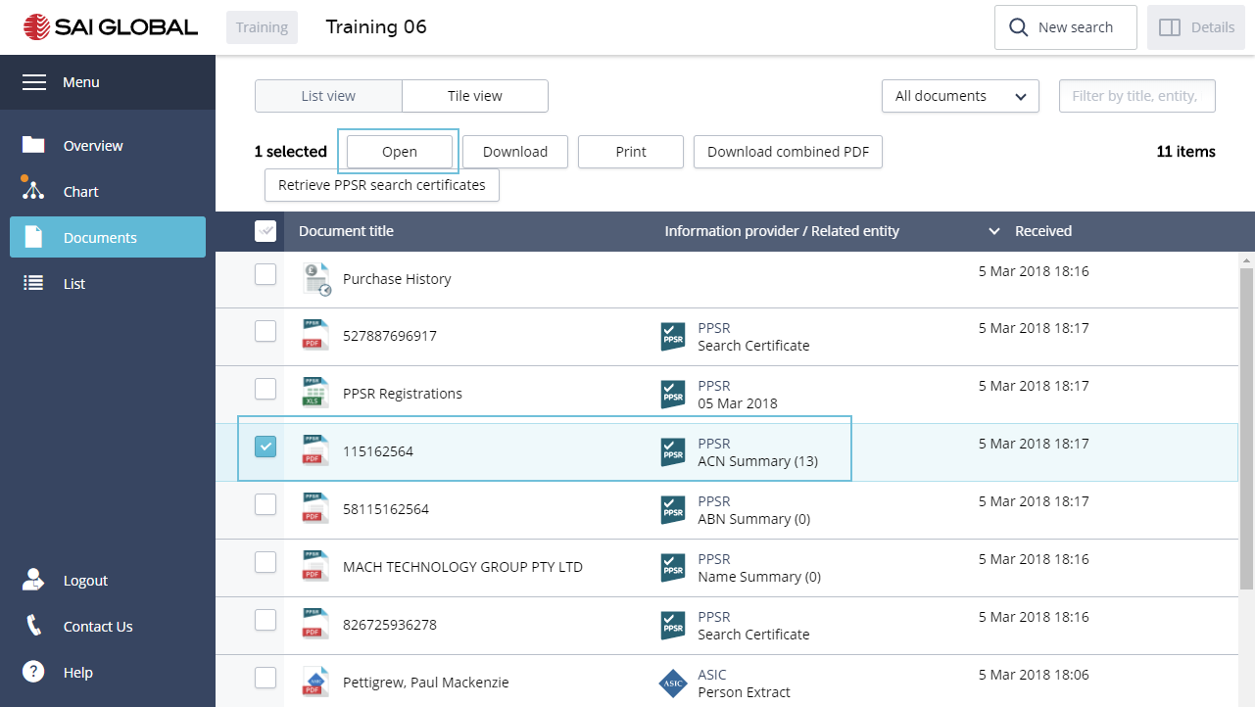
- Close the report.
- Click to display all documents in Tile View
Congratulations you have completed Activity 6

Activity 6 – Check Property Ownership
Still interested in Mr. Pettigrew, you want to understand his situation more clearly. You run a Land Title Search on 568 Lower Bowen Terrace, New Farm Queensland to see who owns the title.
- Using the Chart or List Views, select the address 568 Lower Bowen Terrace, New Farm QLD
- Click on the Follow-on Search button
- Select Address Land Search Lookup Title & Deed
encompass completes the search form for you
- Select the Street Type - Terrace
- Click Submit
The first part of the search is the lookup.
- Click to purchase the Title
encompass will list all the follow on documents that are also available to purchase. De-select those you do not require or click Skip to not purchase any of these documents.
- Skip the follow on documents
- Open the Chart view
As Land Registry has the address lodged with a Lot number, encompass has not been able to match the details with the existing address, and a new entity has been added to the chart.
- Merge the entities
  - Hold down the CTRL key and select both address entities
  - Open the Details panel
  - Click on Merge
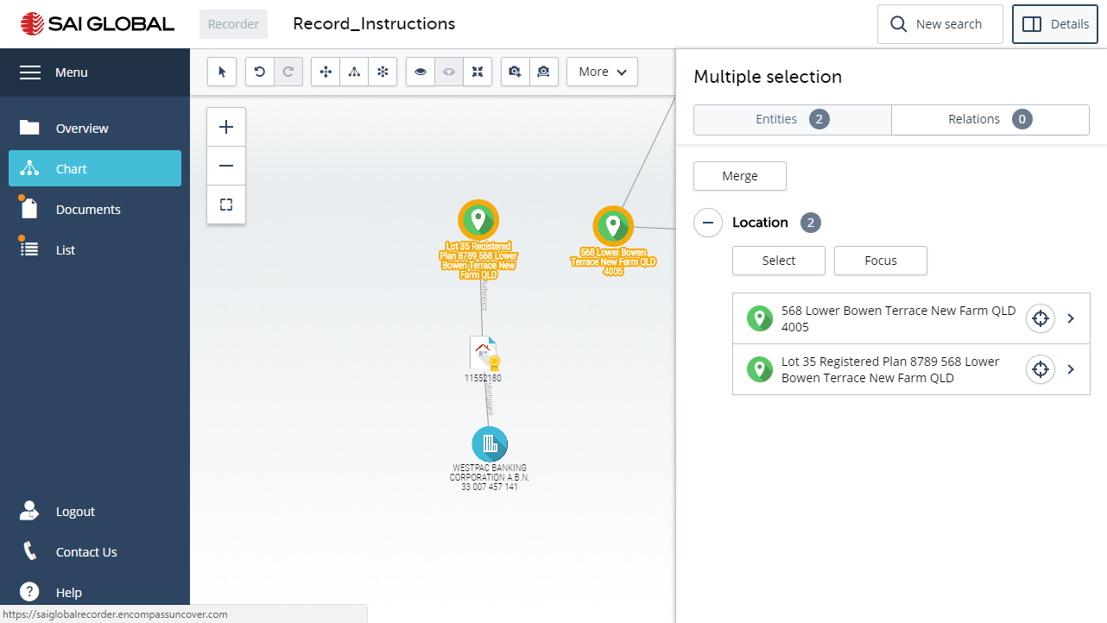
  - Select the Properties you want to display on the merged entity
  - Click Merge
You can unmerge an entity that has been merged. Select the entity and click Unmerge
- Open the Documents view
Here you will see the Land Title you purchased.
There are many additional searches that you can run on the Companies, persons and addresses, and all follow the same process. Select the entity, click on the Follow-on search button and select the search you require.

Google Maps
You want to confirm that the property owned by Mr Pettigrew is not a vacant lot. You check it on Google Maps.
- Right-click on the entity you merged for 568 Lower Bowen Terrace, Newfarm.
- Select Show on Map
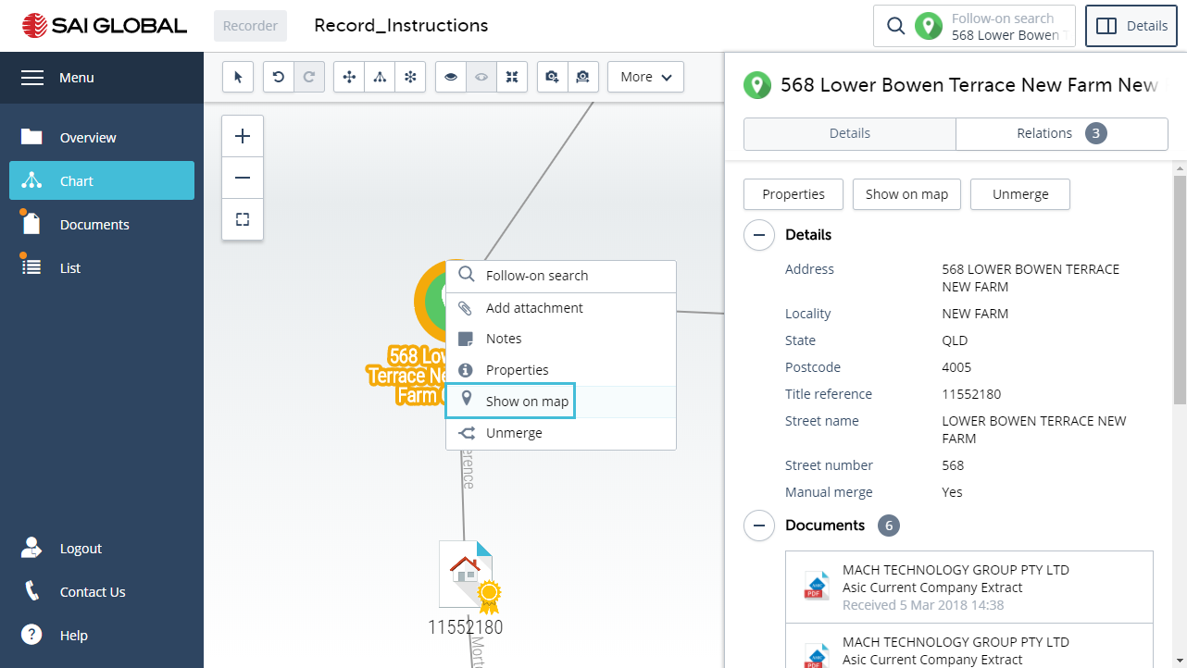
- Click on Street View
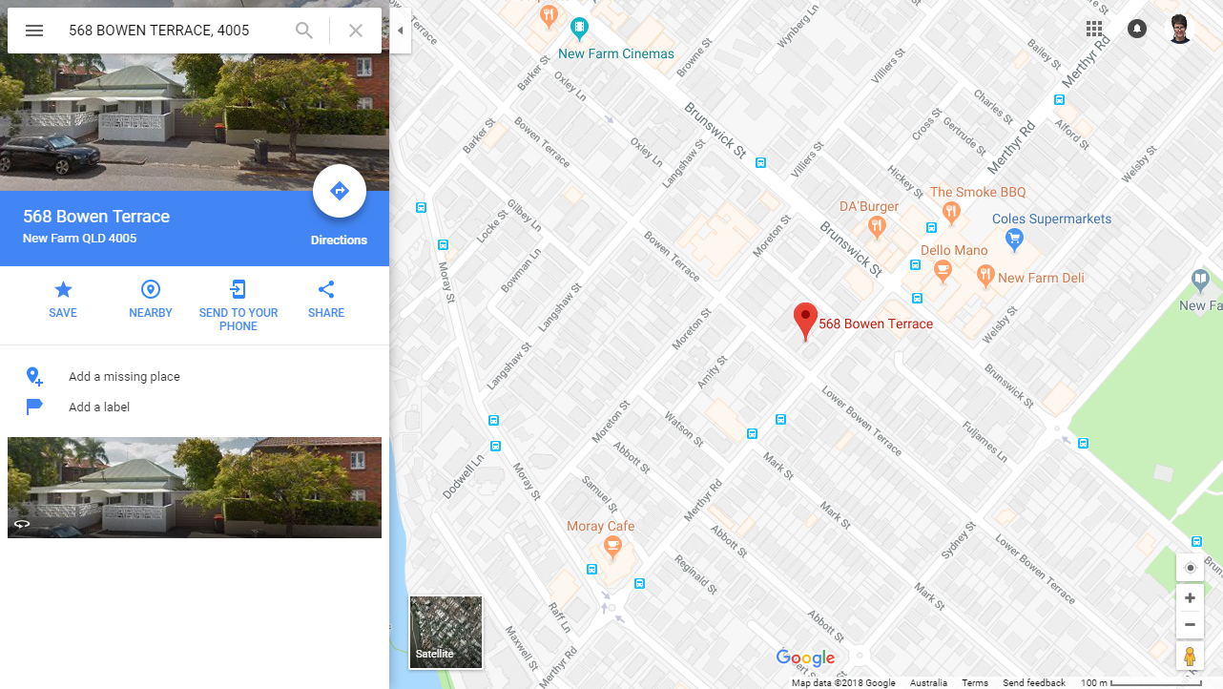
- Close the tab and return to encompass
Congratulations you have completed Activity 6

Activity 7 Share the results
As a final step, you share the workspace with your Manager for review.
- Open the Overview
- Click on Share
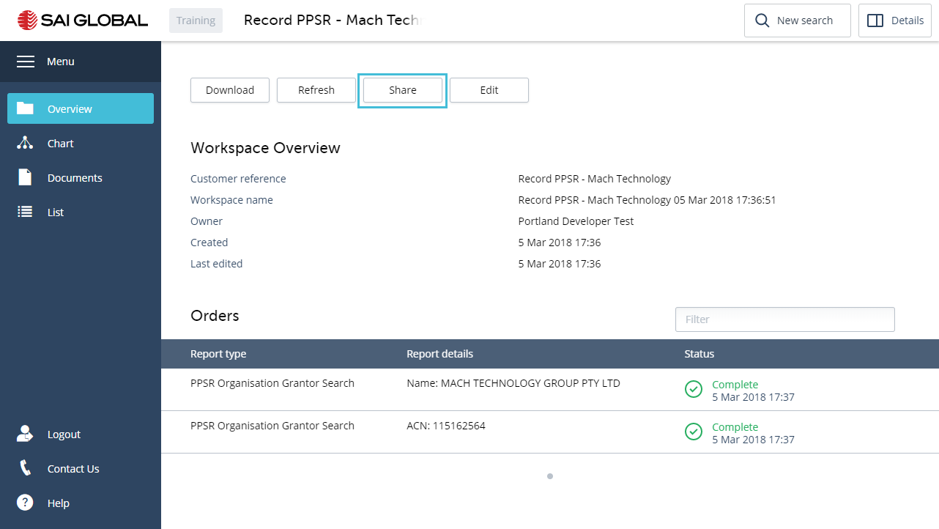
In the Share form you can select to copy a link that will provide access to the workspace. You can then send the link to a colleague or client. You can select whether to send a link where the recipient will be able to make changes to the profile or to view the details only.
- Click on the link. This will copy it to your Clipboard and you can paste it in an email or location of your choice.
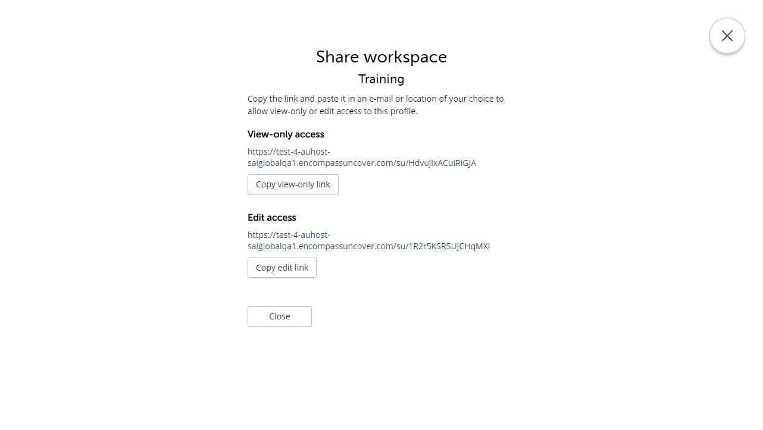
Congratulations this completes Activity 7

Activity 8 – Key Features

Add to the Chart
During your investigations you uncover a Trust exists for the Pettigrew Family and Paul Mackenzie Pettigrew is one of the beneficiaries. To complete the picture, you want to add the details to the visualisation.
- Open the Chart view
- Centre the Chart
- Close the Details panel
- Click on the More Toolbar button
- Select Add entities and relations to the chart
The Edit panel will display.
- Click on Trust
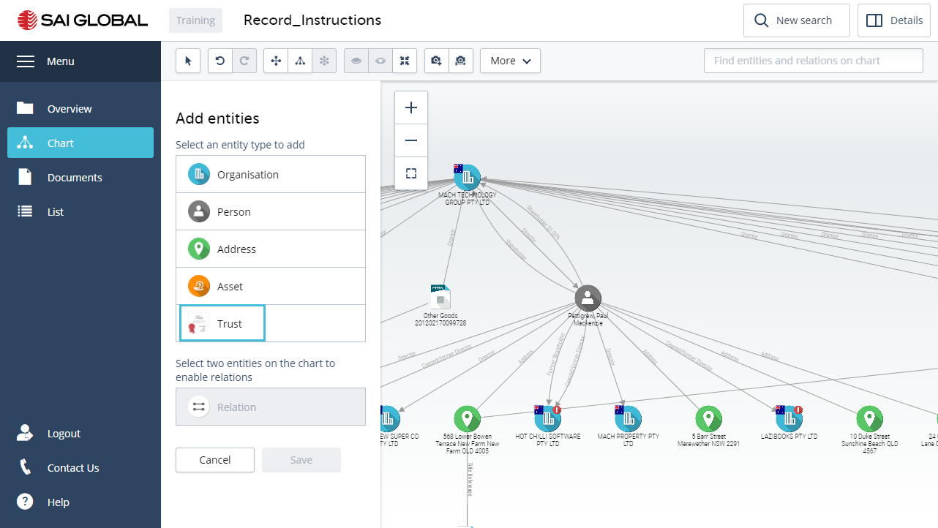
- Enter the Trust Name: Pettigrew Family Trust
- Optionally select a Type of Trust, and enter the Date of the Trust Deed and Last Amendment date.
- Click the Add button.
- Click to select the newly created Trust entity and the entity for Paul Mackenzie Pettigrew (hold down the CTRL key).
- Click the Relation option
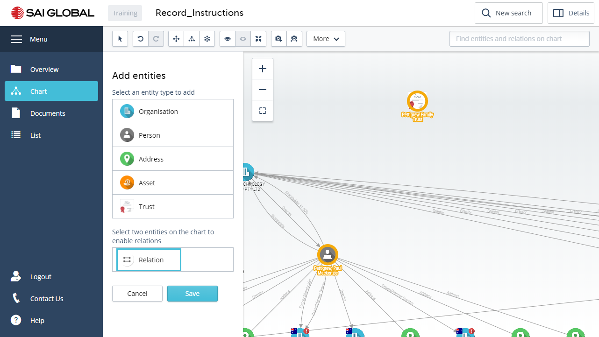
- Select the Type of link - Beneficiary
- Click Add
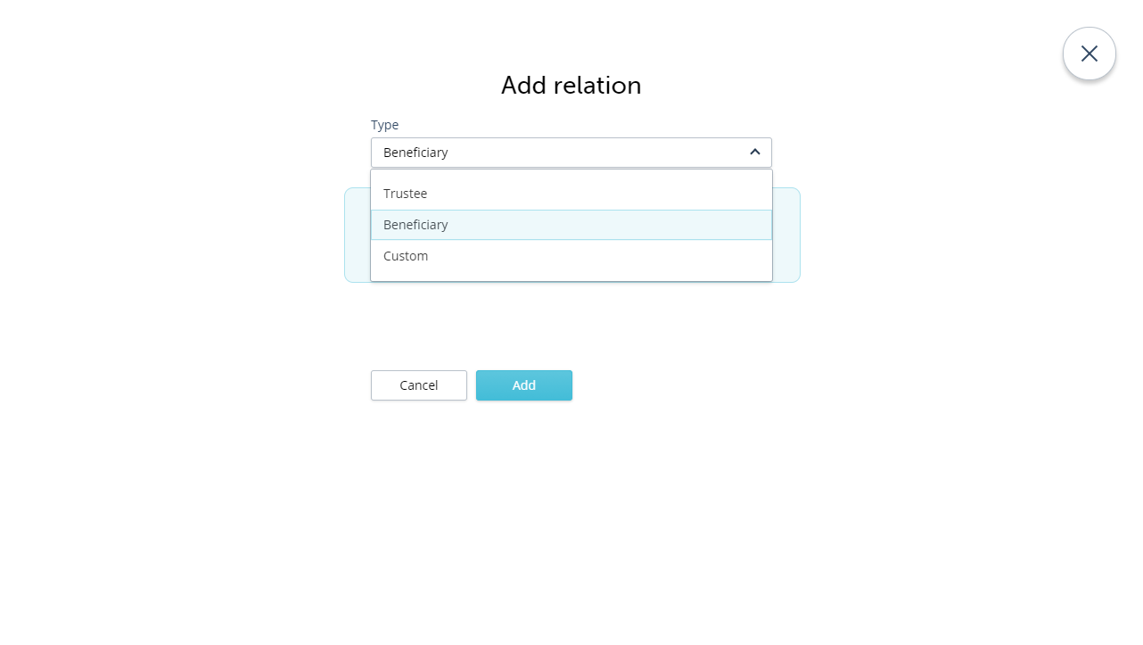
A link is added between the trust entity and the entity for Paul Pettigrew.
- Click Finish
- Name your edit – Pettigrew Family Trust
- Click Save
By naming the edit you have made, you can filter the chart and remove the manual data, as you would for a report.
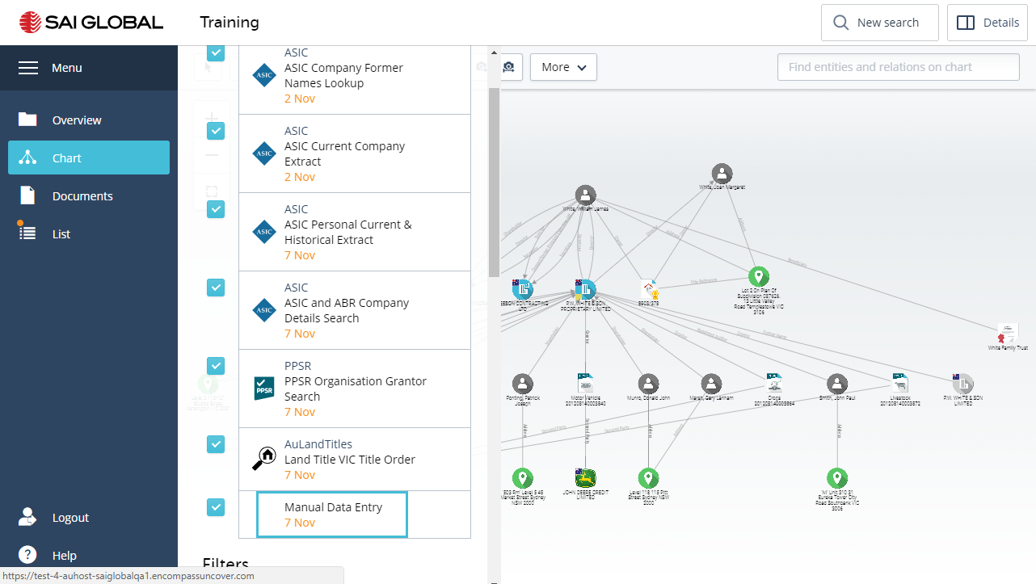

Chart Filter
encompass provides a powerful chart filtering paradigm to enable you to filter large datasets into manageable and distinct views of information. By clicking on the Chart Filter toolbar function (which you will find under the More button), you can open and close a Filtering panel on the left of the workspace.
The Filter panel includes the Reports you have undertaken in the workspace, as well as any manual additions you have made, and a dynamic list of filter sets that are created based on the entities and their properties available in each report.
- Click the More button
- Select Chart Filter
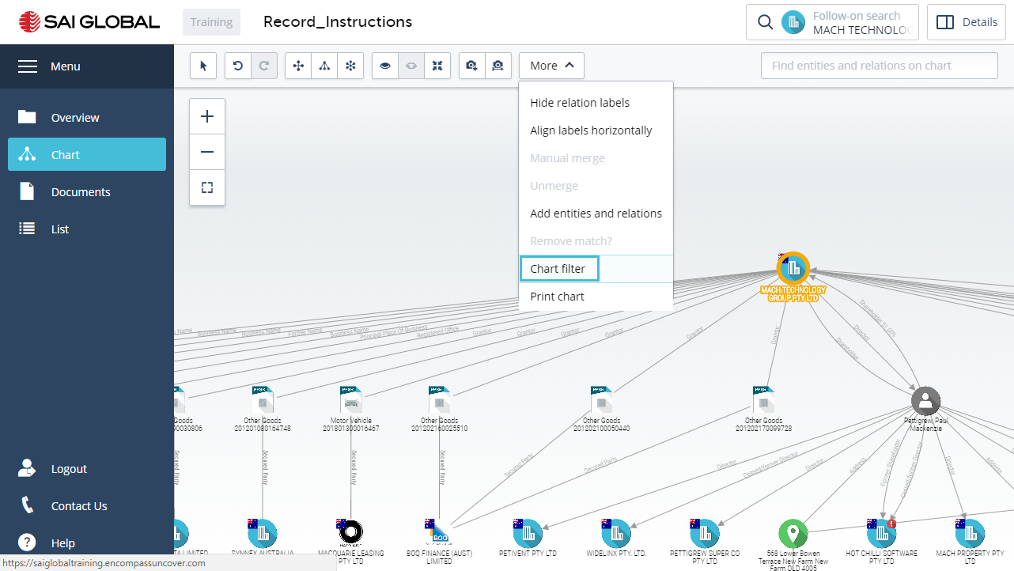
At the top of the Panel you can expand the Reports section, and filter off an entire report.
- Uncheck one of the Reports to see the affect it has on your chart.
- Re-instate the Report
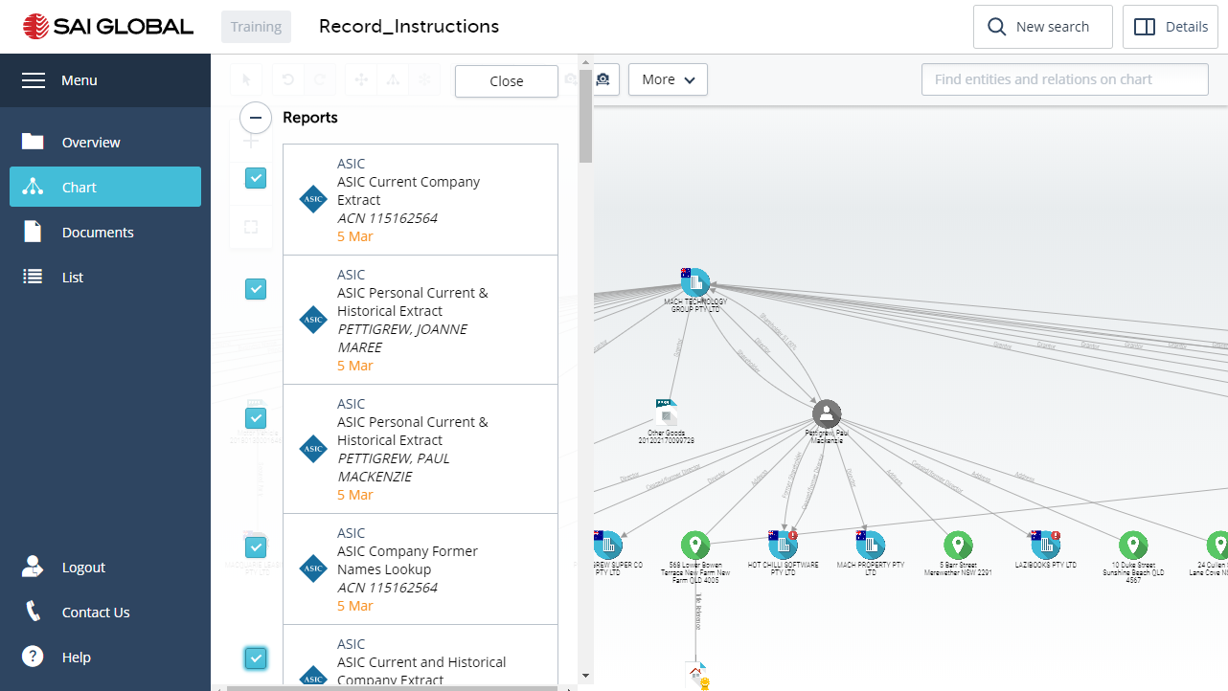
- Collapse the Report section
Here you will see all the Entities and Properties listed as filters.
- The first step is to de-select any of the Categories you do NOT want to see. In this example, please filter off – Locations, Land Titles, PPSR and Trusts
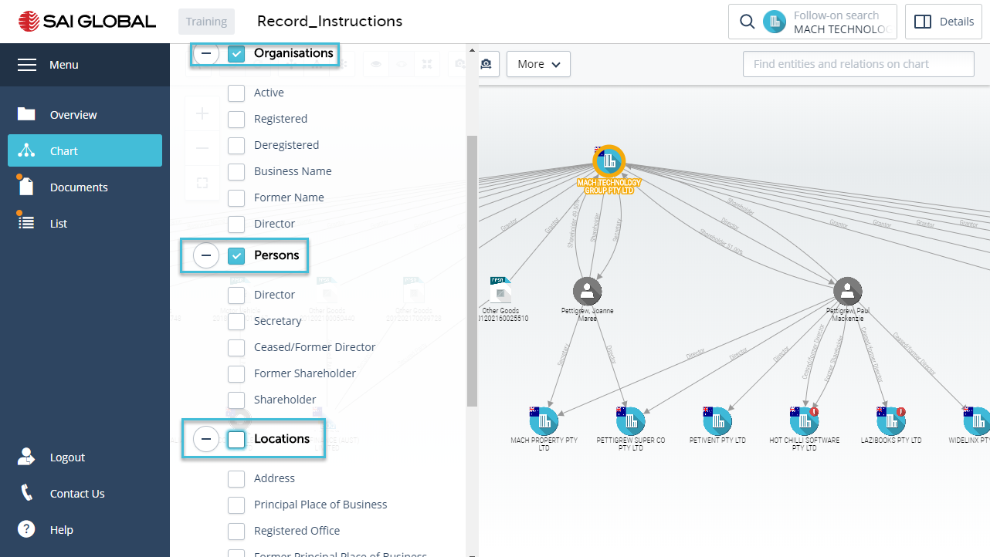
- Under Organisations, select Registered’ (This will show all Organisations in the displayed reports with a status of ‘Registered)
To see the changes, you may need to Close the Chart Filter panel, and apply a hierarchy layout to the chart.
- Under the Persons filter, select ‘Secretary‘’. (This will show only the Secretaries in the Chart.)
- 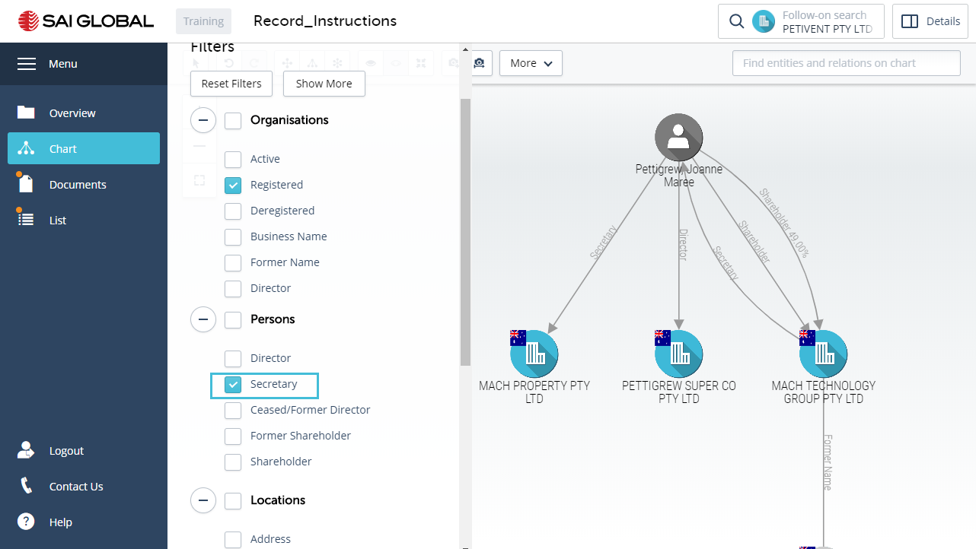
- Take a Snapshot of the chart by clicking on the Create Snapshot Toolbar button
- Name the Snapshot – Registered Companies and Secretaries
- Click Save
- Click on the Snapshot History button
You will see a timeline of all the searches you have done and any Snapshots you have taken.
- Scroll the timeline to the end.
You will see the Snapshot you have taken.
- Click on the camera button
You will note a Restore button which will allow you to always return to the chart in the state you captured it.
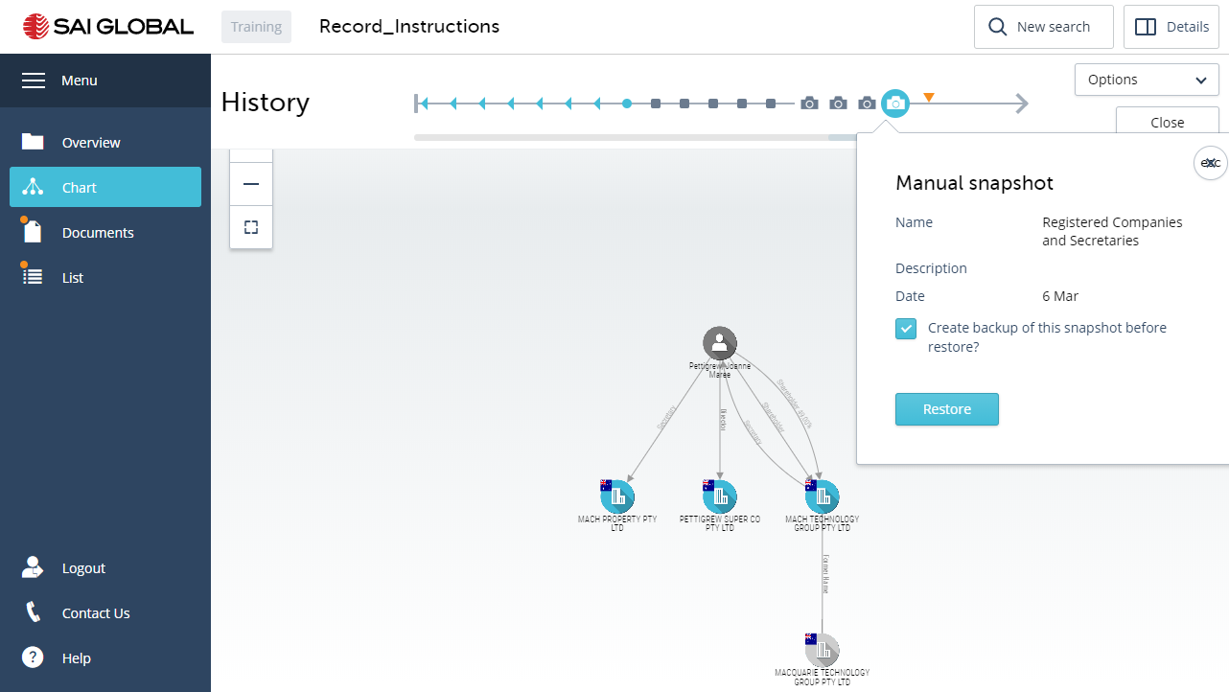
- Close the Timeline
- Open Chart Filter
- Re-instate all the Filter – click Reset Filters
- Close the Chart Filter panel
Congratulations you have completed Activity 8

Activity 9 - In Product Help
Encompass has a comprehensive In Product Help which is available throughout the application by clicking on Help located at the bottom of the Menu.
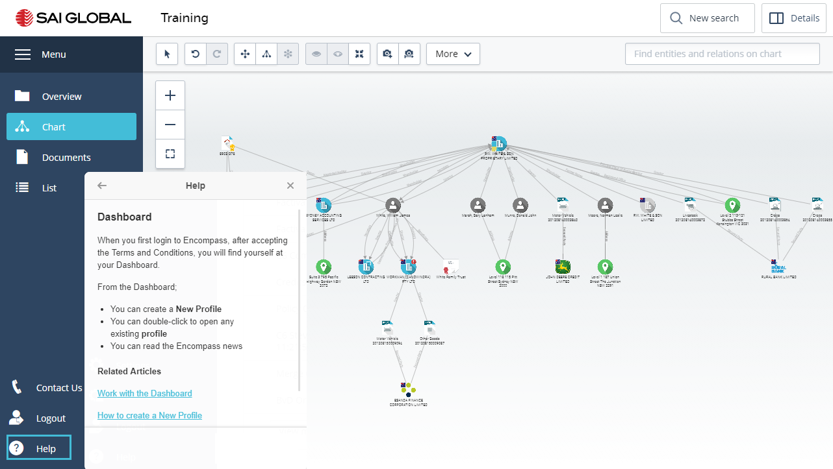
In most cases encompass will suggest an article that is relevant to the view you are in. You can also search for any term, report or feature by entering what you are after in the How can we help field.

Support
Please don’t hesitate to contact Support by clicking on Contact us button in the menu;

Notes:

Appendix A – Chart icons
Encompass uses a unique set of icons to visually display search results. Visualisation provides a rapid way for you to understand the information and to share it with others.
The icons are divided into broad categories of People, Organisations, Locations and Documents. Some of the categories contain a number of different types of icons; for example Organisations contain different icons for Public and Private Companies. These icons are displayed in different colours to denote the status of the company; such as “Registered” or “Strike of Action in progress. You may also see additional symbols overlaid on an icon such as a “red warning triangle” – This is used to provide an additional visual indicator that this icon may be of particular interest.
There are a number of documents that are visualised particularly from registers such as the PPS Register. A number of document icons are used to show a specific aspect of the document, for example PPSR icons emphasise the collateral class of the registration.
Organisations
Private Company  (also used for other entities listed with ASIC that are not Public Companies or Businesses) | Private Company Deregistered or Former Name | Private Company under external administration | Private Company Warning
Public Company | Public Company Deregistered or Former Name | Public Company under external administration
Business | Business Former Name or Deregistered
People |  | Locations
Generic icon for males and females | Warning symbol applied when a Person has a bankruptcy history | Used for all addresses
ASIC
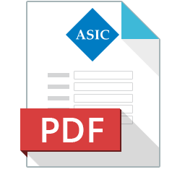  ASIC FORM | ASIC Charge | ASIC Banned Disqualified - Match | 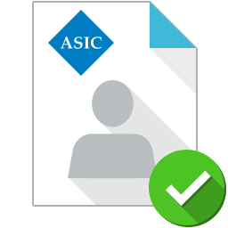  ASIC Banned Disqualified - No Match
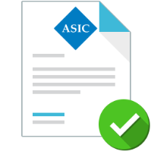  ASIC Licence Active | ASIC Licence Not Active | ASIC Extract Document | ASIC Business Extract Document
ASIC Multiple Extracts

AFSA
AFSA Bankruptcy - Match | AFSA Bankruptcy - No Match
Land Title
Land Title Document | Plan | Instrument | Land Title Historical
PPSR
PPSR Copyright | 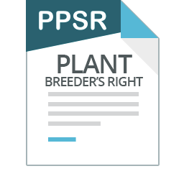  PPSR Plant Breeders Right | PPSR Intellectual Property | 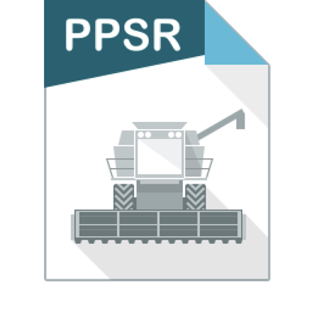  PPSR Crop
PPSR Aircraft Engine | 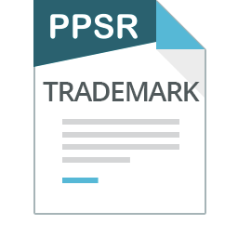  PPSR Trademark | PPSR Circuit Layout | PPSR Patent
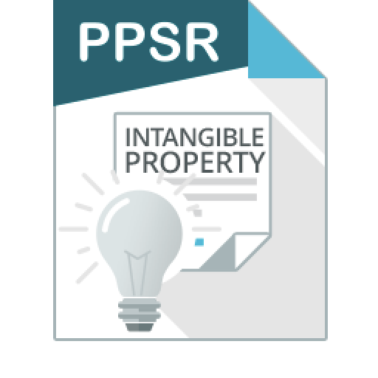  PPSR Intangible Property | PPSR Design | PPSR Helicopter | PPSR Document of Title
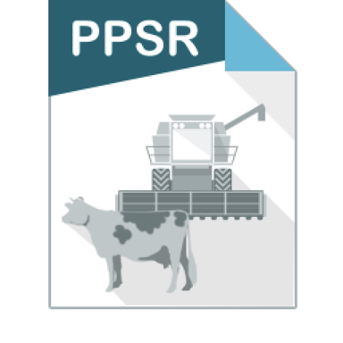  PPSR Agriculture | 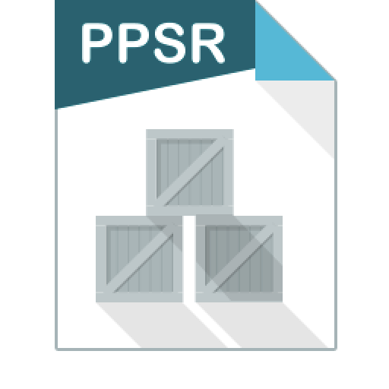  PPSR ALLPAAP no exception | 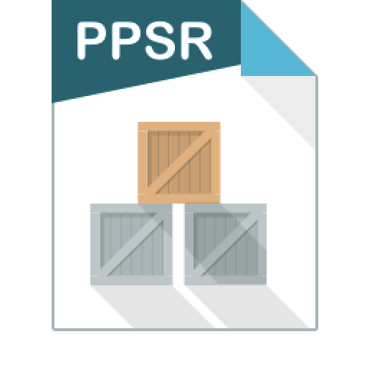  PPSR ALLPAAP with exception | PPSR Airframe
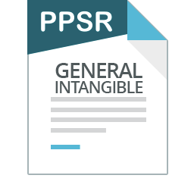  PPSR General Intangible | PPSR Motor Vehicle | PPSR Small Aircraft | PPSR Livestock
PPSR Chattel Paper | PPSR Financial Property | 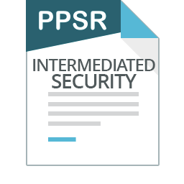  PPSR Intermediated Security | 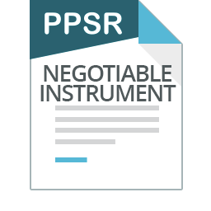  PPSR Negotiable Instrument
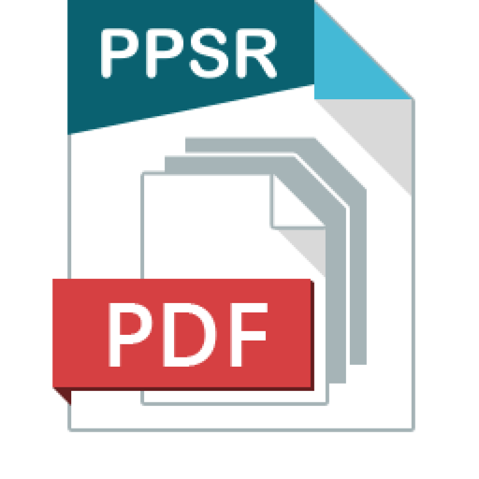
PPSR Combined Certificates (>100)

Trulioo (formerly GDC)
Identity Verified | Identity Not Verified

RP Data
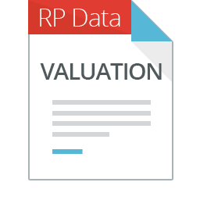  Automatic Valuation | 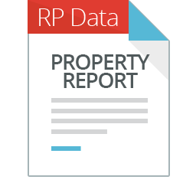  Property Report | 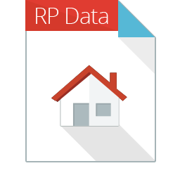  Property Attributes | 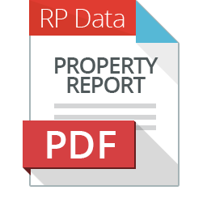  Property Document

Appendix B - Types of Searches
ABR
This search of the Australian Business Register enables verification of Sole Traders, Partnerships and Trusts who do not exist in ASIC. The search will display the entity name and any former names you request to be visualised. The creation of a chart enables you to run additional searches such as PPSR searches or to attach relevant documents such as Trustee information.
ASIC
Company Business Search - Example
The Company Business Search provides information on organisations and business names recorded in ASIC registers.
Some of the organisation types that can be searched include:
- Companies
- Business names
- Registered bodies
- Foreign companies
- Associations
- Managed investment schemes
and
- Non-registered entities.
The information you receive will depend on the type of organisation you are searching for and can include; current business name details, former State and Territory registration details, address details including principal place of business and registered address, business name holder details and office holder details.

Company Current Extract
This report provides current company details such as ACN, ABN, registration date, current address details, office holders and their roles such as Directors, Shareholders and Company Secretaries. Any external administrators (if applicable), auditors, share information and a list of documents registered with ASIC such as ASIC Forms.
Company Current and Historical Extract
This report identifies all the Current Company Extract details as shown above, as well as historical details for each category of information.
Company Relational Extract
This report will provide the following details where relevant;
- Companies in which the subject corporation is a member (only the top twenty members),
- Companies for which the subject corporation is the Ultimate Holding Company,
- Corporations for which the subject corporation is a director,
- Foreign companies for which the subject company is a local agent,
- Financial Services licenses held by the subject company,
- Financial Services representative roles held by the subject company,
- Auditor roles in Financial Services licenses held by the subject company,
- Securities dealers licenses held by the subject company,
- Securities investments advisers licenses held by the subject company,
- Futures dealers licenses held by the subject company,
- Futures advisers licenses held by the subject company.
- Managed Investment schemes for which the subject is the responsible entity.
The report includes; current organisation details, roles in other organisations, previous roles in other organisations, and previous shares and interests held.
Note: This report does not include office holders.
If you search for an ASIC Relational Extract and one is not held by ASIC, you will not be charged for the search.
ASIC Person Current and Historic Extract
This report provides current and historical details on an individual, such as name, current and historical roles held, including current and previous address details.
ASIC Person Banned and Disqualified Reports
The Banned & Disqualified search provides information about people who have been disqualified from involvement in the management of a corporation, or banned from practicing in the financial services or credit industry.
ASIC Company Documents
With a company on your chart, you can request Company Documents by right-clicking on the Company icon.
You will receive images of the Company documents.
AFSA
AFSA Persons Bankruptcy Check
You can perform an Insolvency and Trustee Service Australia (ITSA) bankruptcy search of the National Personal Insolvency Index (NPII) database to see details on bankruptcies recorded against individuals.
The search result provides the following information for individuals listed in the database, although not all data may be held by ITSA for each individual. The information includes:
- Date of Birth
- Date of Death
- Address
- Occupation or Business Details
- Administration Numbers
- Type of Order
- Dates of Bankruptcy
- Date of Entry on the NPII
- Trustee
- Administration
- Petitioning Creditor's & Solicitor's Names
- Court Reference
- Dates and Hearing Results
Note: a red warning symbol is applied to the Person icon when there is a bankruptcy history. This symbol does not indicate that the person is currently bankrupt.
Documents are linked to the Person in your chart with a red cross or green tick to indicate whether a match was found on the registry.
PPSR
PPSR Organisation Grantor Search
This searches the PPS Register for registrations listed against Organisations based on their Name (current and former), ABN and ACN. This search allows you to conduct a Name (current and former), ABN and ACN search together with the option of also purchasing ASIC current and current and historical extracts on the company.
This search will return a PPSR Summary, Search Certificates and Attachments.
PPSR Filtered Organisation Grantor Search
A PPSR filtered Organisation Grantor Search is a Grantor Search on an Organisation where the searcher can specify the registrations for specific collateral classes and other criteria that they wish to include or filter out of their search.
PPSR Person Grantor Search
Searches the PPS register for all registrations that have an exact match against your search criteria which must include given name, family name and date of birth as mandatory fields.
If you are intending to search using an individual’s details you must have an authorised purpose to search. Generally, the person/s that can search the PPS Register are an:
- Individual with their consent
- Individual or organisation needing to decide whether to provide credit to a person or organisation
- Individual or organisation needing to decide whether to invest in, with or through a person or organisation
- Individual or Organisation needing to establish if personal property is subject to an existing security interest.
PPSR Registration Number Lookup
Search the PPS Register by the PPS Registration number.
PPSR Motor Vehicle
Search the PPS Register for a Motor Vehicle by entering the VIN number.
Land Title Registries
Company Land Search Lookup Title and Deed
A Title Search confirms the current owners of a property and shows any registered interests affecting the property such as a mortgage or easement. You may need to perform a Land Title Lookup first in order identify the title number.
Person Land Search Lookup Title Deed
This search provides details on Land Titles (property) held by an individual. Users need to select the State in which to conduct the search.
Land Title Reference Lookup
Search for the Owner of a property by Reference Number.
Land Search Lookup Title Deed
Search for the Title Deed of a property by its address.
Trulioo
Trulioo (formerly Global data Corporation) Personal Verification uses publicly available sources to perform a “minimum KYC (Know Your Customer)” check. There are 8 data sources checked by this product, where a successful verification is reported if:-
- A match on name and address is obtained on (at least) one data source
OR
- A match on name and date of birth is obtained on (at least) one data source
This search can only be conducted on People.
Data sources include:-
- Australian Citizen File (requires Last Name, Postcode)
The name, residential address and date of birth of persons who currently reside in Australia.
- Australian Property Owner File (requires Last Name, Postcode)
The names and addresses of residential persons in Australia that have made a property purchase, including some of their co-inhabitant family members.
- Australian National Telephone Directory (requires Last Name, Postcode)
Derived from the Integrated Public Number Directory (IPND) which is an amalgamation of all Australian telephone carriers.
- Australian Telephone Transaction History (requires Last Name, Postcode)
Created from an analysis of historical data contained within a national telephone database compiled and maintained by GDC, on phones registered at an address for a consecutive period of 3 years or more.
- Tenancy File (requires Last Name, Street Name, Postcode)
The database contains the name, and date of birth of persons who rent property in Australia.
- ASIC People Search (requires First Name, Last Name, Date of Birth)
The name and date of birth of all persons who are registered as directors or company officers with ASIC.
- Trulioo Australian Historical File (requires Last Name, Street Name, Postcode)
An analysis of historical data contained within the Australian Citizen File derived from historical databases held by Trulioo, augmented by third party sources such as change of address data, data pooling and other public sources.
- Data Cooperative (requires First Name, Last Name, Street Number, Street Name, Postcode)
The name and residential address of persons who currently reside in Australia derived from a range of organizations that collect the data directly from their customers and share the data for identity verification purposes. In addition, the database is comprised of records of persons who have made financial commitments to commercial organisations.

RP Data
RP Data offers a range of real estate based data products that can be incorporated into the Encompass chart, including:-
- RP Autoval
This product performs an automated valuation of a property. This can be launched from the menus or from a right click on either a Location or Property icons. To obtain a more accurate valuation, you can update the property characteristics. (This is not a permanent update).
- RP Property Report
This product report focuses on the property, providing comprehensive details which can include legal property characteristics (e.g. number of beds/baths/car spaces/floor space, lot plan details, titles, etc.), the owner, the vendor (and any relationship between them), the agency (and agent) brokering the sale, sales, listing and rental histories, photographs, aerial and cadastral maps, and more.
RP Property Profile
This is a combination of the Auto Val and Property Reports, plus a comprehensive study of the area, other properties for sale, rent and statistics etc.
In addition, to the above reports, the Owner and Vendor (either of which may be a person or organisation), plus the relationship between them (if one exists), will be added to the chart.

Australian Registered Body Number [ARBN]
Australian Registered Scheme Number (ARSN) is a nine digit number issued to Australian managed investment schemes by ASIC.
Note that some foreign companies are registered with ASIC for reporting purposes

